­

|  |
| --- |
| TECHNICAL  ENGLISH  FOR 2nd DAM |
|  |
| ISABEL OTERO |



Contents

QUESTION WORDS 7

PERSONAL INFORMATION QUESTIONS (name,address, job,age etc 8

KINDS OF QUESTIONS: 8

* Yes / No Questions Auxiliary + Subject+ Verb 8
* Wh- Questions 8
* Object questions 8
* Subject Questions 8
* Indirect Questions 9
* Question tags: 9
* So Do I / Neither do I 9

CAREERS/EMPLOYMENT/COMPANIES 20

COLLOCATIONS (NOUN COMBINATION) WITH THE WORD *CAREERS* 20

VOCABULARY (MONEY) 20

EMPLOYMENT 21

JOB INTERVIEWS 29

TIPS FOR JOB INTERVIEWS SUCCESS 29

FREQUENT QUESTIONS IN A JOB INTERVIEW 29

POPULAR SKILLS THAT EMPLOYERS WANT 31

PERSONAL QUALITIES 31

NOUN SUFFIXES 33

MOST COMMON PREFIXES 39

MOST COMMON SUFFIXES 42

TELEPHONING 47

* Kind of calls at work: 47
* Useful language 47
* Answering the phone 47
* Identifying yourself 47
* The reason for the call: 47
* Identifying the caller: 47
* The person you want to talk to is in the office 47
* Asking the caller to leave a message 47
* Leaving a message 48

ENGLISH TENSES: PRESENT, PAST AND FUTURE 54

**PRESENT SIMPLE** 54

SPELLING: 54

USE: 54

* Habitual actions, routines, habits (normally with a frequency adverb) 54
* Permanent situations 54
* FREQUENCY ADVERBS 54
* Position 54

**PRESENT CONTINUOUS:** 55

* SPELLING: 55
* USE: 55

**FUTURE** 56

* **THE PAST /**Adverbs used with the Past/Use 56

**PAST CONTINUOUS** 57

**PAST PERFECT** 57

**MODAL VERBS** 61

CAN/COULD/BE ABLE TO 61

COMPARE: 62

MUST: 62

MUST NOT /NEED NOT COMPARED 62

POSSIBILITY 62

DEDUCTIONS 63

USED TO 63

BE USED TO + -ING FORM 63

GET USED TO + -ING FORM 63

# 1st TERM

# CONTENTS

* WORKING IN I.T
* PARTS OF A COMPUTER /ASSEMBLING A COMPUTER
* PHONETICS: THE TWELVE VOWELS
* WORK, COMPANIES AND EMPLOYMENT
* JOB INTERVIEWS /APPLYING FOR A JOB
* CV´s
* NUMBERS

# FUNCTIONS

* TELEPHONING
* REQUESTS, PERMISSION, THANKS AND APOLOGISING
* GIVING INSTRUCTIONS
* EXPRESSING POSSIBILITY, ADVICE, PROHIBITION, ABSENCE OF OBLIGATION

# WRITING ACTIVITIES

* WRITE YOUR CV

# GRAMMAR

* Questions /Personal information /Order in questions
* Numbers
* Instructions
* Review of tenses: Present simple and continuous /Past simple and continuous / Future
* Word formation: prefixes and suffixes to form adjectives, nouns and adverbs
* Modal verbs
* Used to / to be used to + ing
* Subject and object pronouns, possessive adjectives and pronouns

# 

# 2ND TERM

# CONTENTS

* TROUBLESHOOTING
* EMAILS AND LETTERS
* BUSINESS SKILLS FOR I.T
* ONLINE SAFETY
* TRENDS /GRAPHS

# FUNCTIONS

* PRESENTATIONS
* NEGOTIATIONS
* ASKING FOR AND GIVING DIRECTIONS
* COMPARING
* WRITING ACTIVITIES
* EMAILS AND LETTERS: APPLICATION LETTER, COMPLAINT EMAIL, CV, QUOTES,RECOMMENDING SOFTWARE ETC
* MEMOS: MEMO ABOUT COMPANY CYBER SECURITY
* REVIEW OF A COMPUTER GAME

# GRAMMAR

* Present Perfect
* Comparative and superlative of adjectives and adverbs/Expressing degree
* Countable/Uncountable nouns /Quantifiers: some, any, few, little, many, much etc
* Conditional sentences
* Relative pronouns and relative clauses
* Passive voice
* Linkers
* Present perfect: yet, already, for, since…

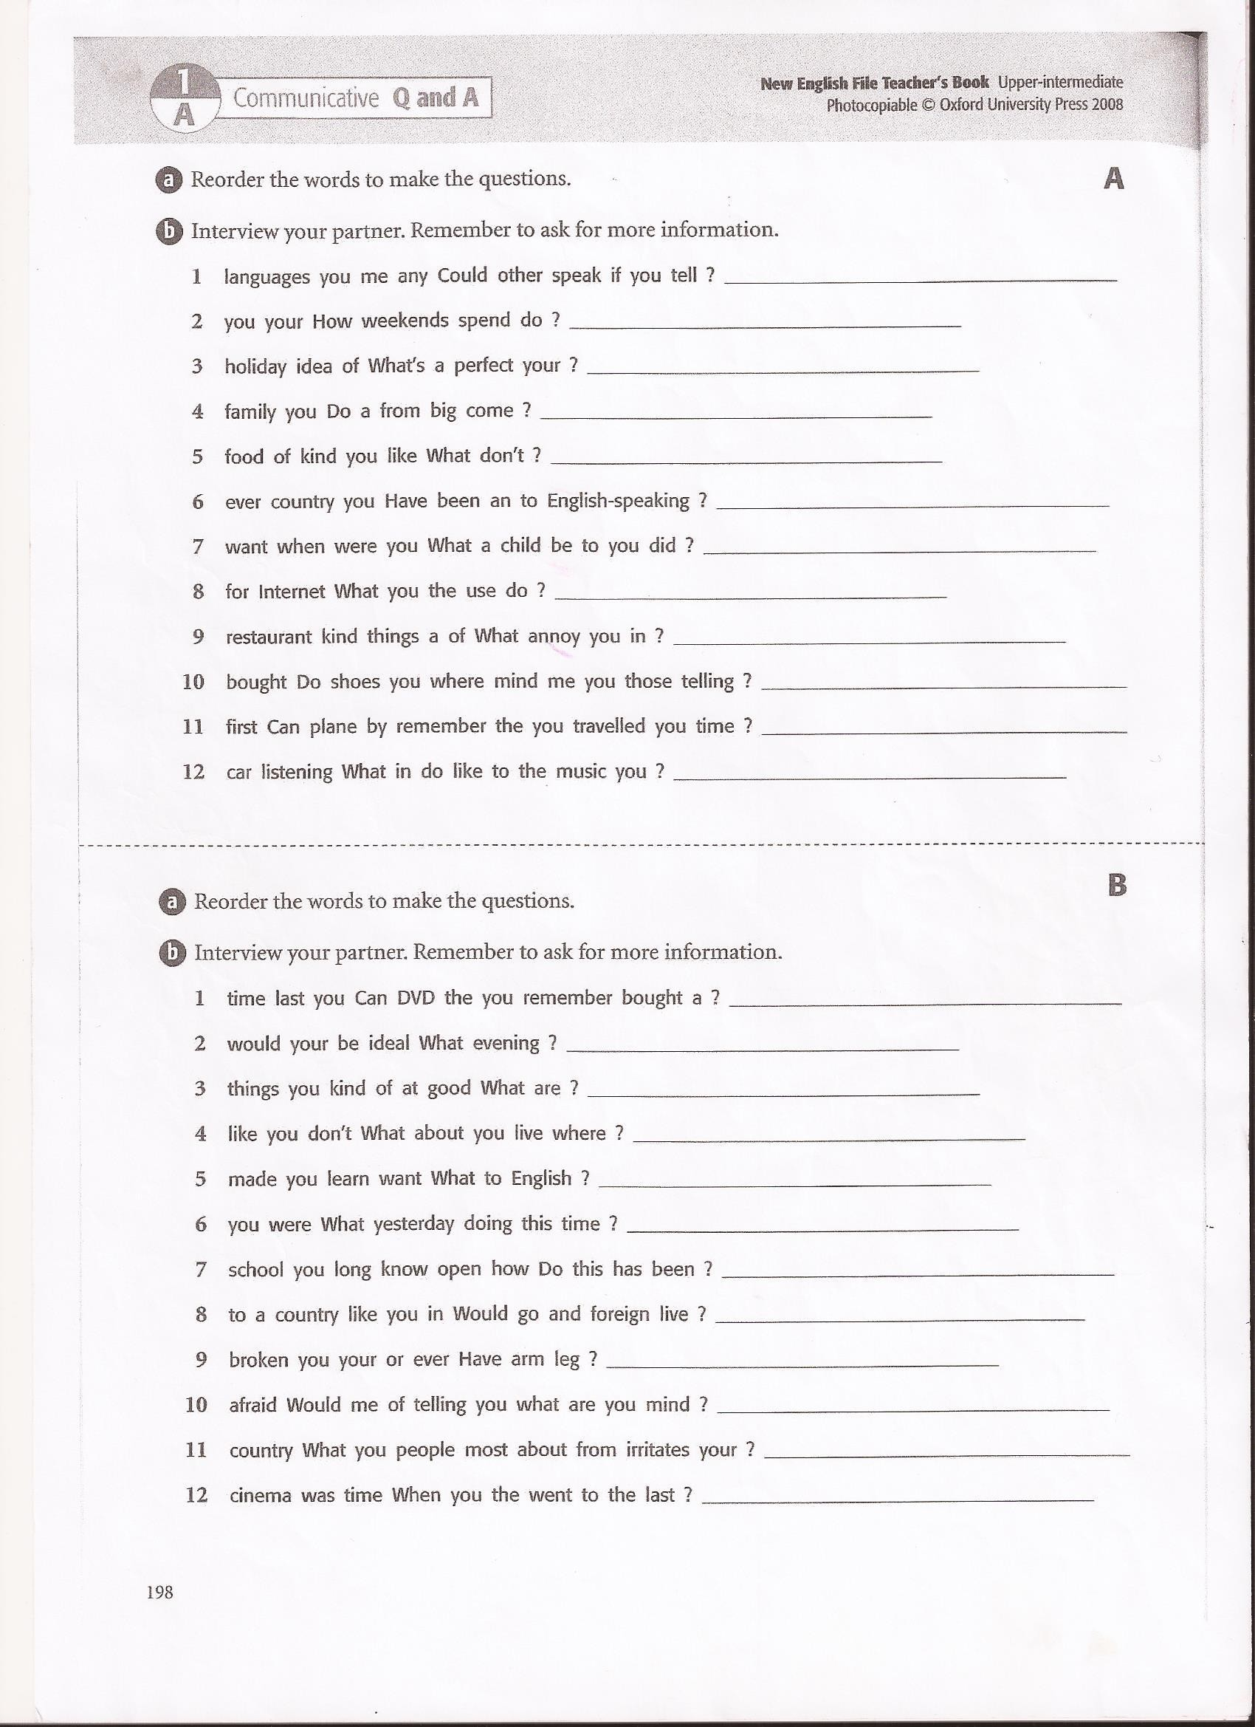

|  |  |
| --- | --- |
| QUESTION WORDS | |
| *WHAT*  *Qué* | ***What are you doing?***  ***¿Qué estás haciendo?*** |
| *WHICH*  *Cuál*  *(entre opciones)* | *Which colour do you prefer red or blue?*  *¿Qué o cuál color prefieres?* |
| *WHO*  *Quién* | *Who do you live with?*  *Con quién vives?* |
| *WHERE*  *Dónde* | *Where did you go yesterday?*  *¿Dónde fuiste ayer?* |
| *WHEN*  *Cuándo* | *When were you born?*  *¿Cuándo naciste?* |
| *WHAT TIME*  *A qué hora?* | *What time do you usually get up?*  *¿A qué hora te levantas normalmente?* |
| *HOW MANY*  *Cuántos contables* | *How many shirts did you buy?*  *¿Cuántas camisas compraste?* |
| *HOW MUCH*  *Cuánto-a (incontables)* | *How much sugar do you want? ¿Cuánta azúcar quieres?*  *How much is it? ¿Cuánto cuesta?* |
| *HOW OFTEN*  *Con qué frecuencia* | *How often do you play football?*  *¿Con qué frecuencia juegas al fútbol?* |
| *HOW LONG*  *Cuánto tiempo* | *How long does it take you to come to school?*  *¿Cuánto tiempo tardas en venir a clase?* |
| *WHY*  *Por qué* | *Why are you crying? - ¿Por qué estás llorando?*  *Because I lost my wallet - Porque perdí mi cartera* |

El orden de las preguntas es:

Question word + auxiliary + sujeto + verbo principal

# PREGUNTAS DE INFORMACIÓN PERSONAL

Name (nombre): **What is your name?** My name is Pam

Surname (apellido): **What´s your surname?** My surname is Smith

Age (edad) **How old are you?** I´m 24 years old

Job (trabajo) **What do you do?** /What´s your job? I am an architect/ I work as a waiter

Nationality (nacionalidad) **Where are you from?** I´m from Canada /I´m Canadian

Maritalstatus (estado civil) **Are you married?** No,I´m not, I´m single

Family (familia) **Do you have any children?** Yes, I do, I have three children, two boys and a girl

Hobbies: **What do you like doing in your free time?** I like skiing and reading

City (ciudad) **Where do you live?** I live in Liverpool

Address (dirección) **What´s your address?** My address is 25 Oxford Street

Emailaddress**: What´s your email address?** My email address is pamsmith 67 at gmail dot com

# QUESTIONS

# Yes / No Questions Auxiliary + Subject+ Verb

Are you German? Yes, I am /No I am not

Do you speak Italian? Yes, I do / No, I don´t

Can you swim? Yes, I can / No, I can´t

Is she dancing? Yes, she is /No she isn´t

Did your sister go? Yes, she did /No, she didn´t

# Wh- Questions

Object questions: Question word (How, Where, Why .....) + Aux. + Subject + Verb

Ex: How many employees do you have in your company?

Why are you laughing?

In these questions the question word is not the subject of the verb (but the object), the subject is you

Subject Questions: Question word + verb +complements

Ex: Who lives here? (the subject is who )

What is happening upstairs? (the subject is what)

# Indirect Questions

Do you know ....... Could you tell me ......................... I wonder ................

We don´t ask the question directly but we start with one of the previous expressions. In these questions there is no inversion of subject and verb

Ex Compare: Direct: How old are you?

Indirect: Can you tell me how old you are?

Direct: Where does he live?

Indirect: Do you know where he lives? (we don´t use the auxiliary does , because the question form appears in **Do you know** .

Direct: Do you smoke?

Indirect: I wonder if you smoke

# Question tags:

You smoke, don´t you?

She isn´t Spanish, is she?

You like pizza, don´t you

# So Do I / Neither do I

I like football / So do I / I don´t/ Me too

I am Spanish / So am I / I am not / Me too

I don´t speak Japanese / Neither do I / I do /

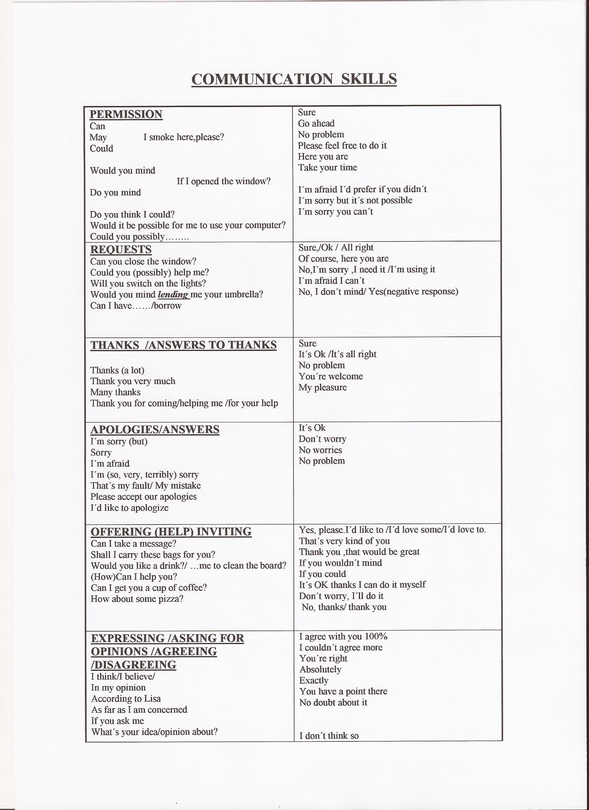

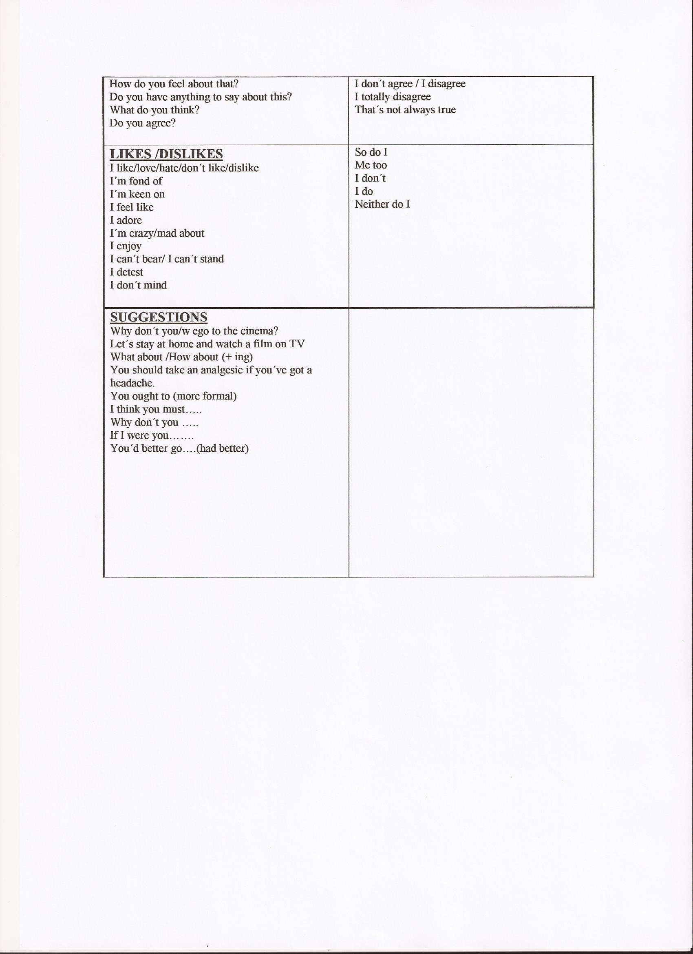

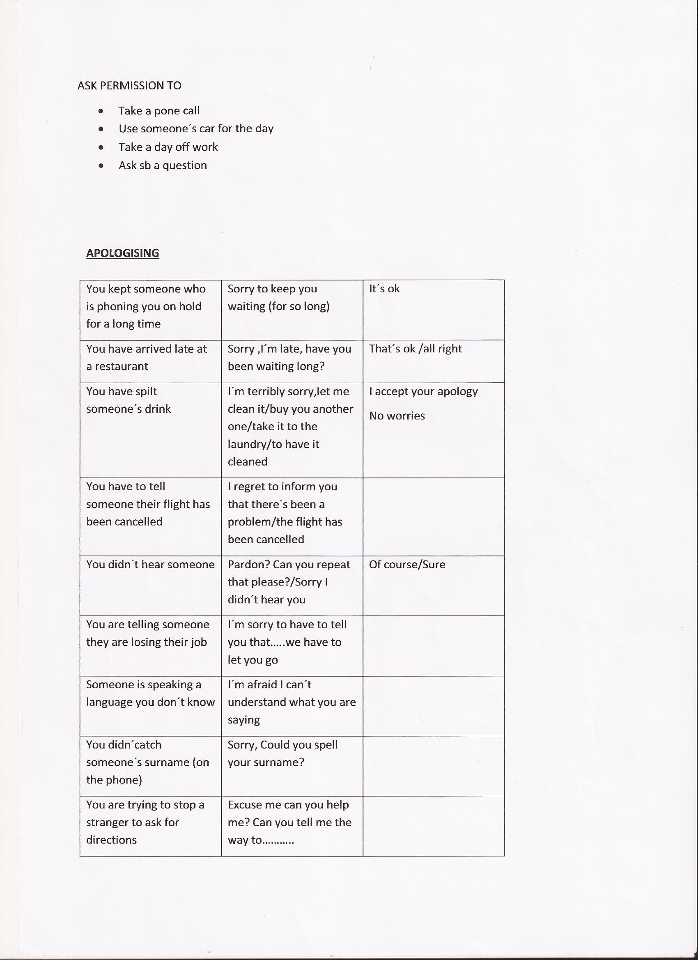

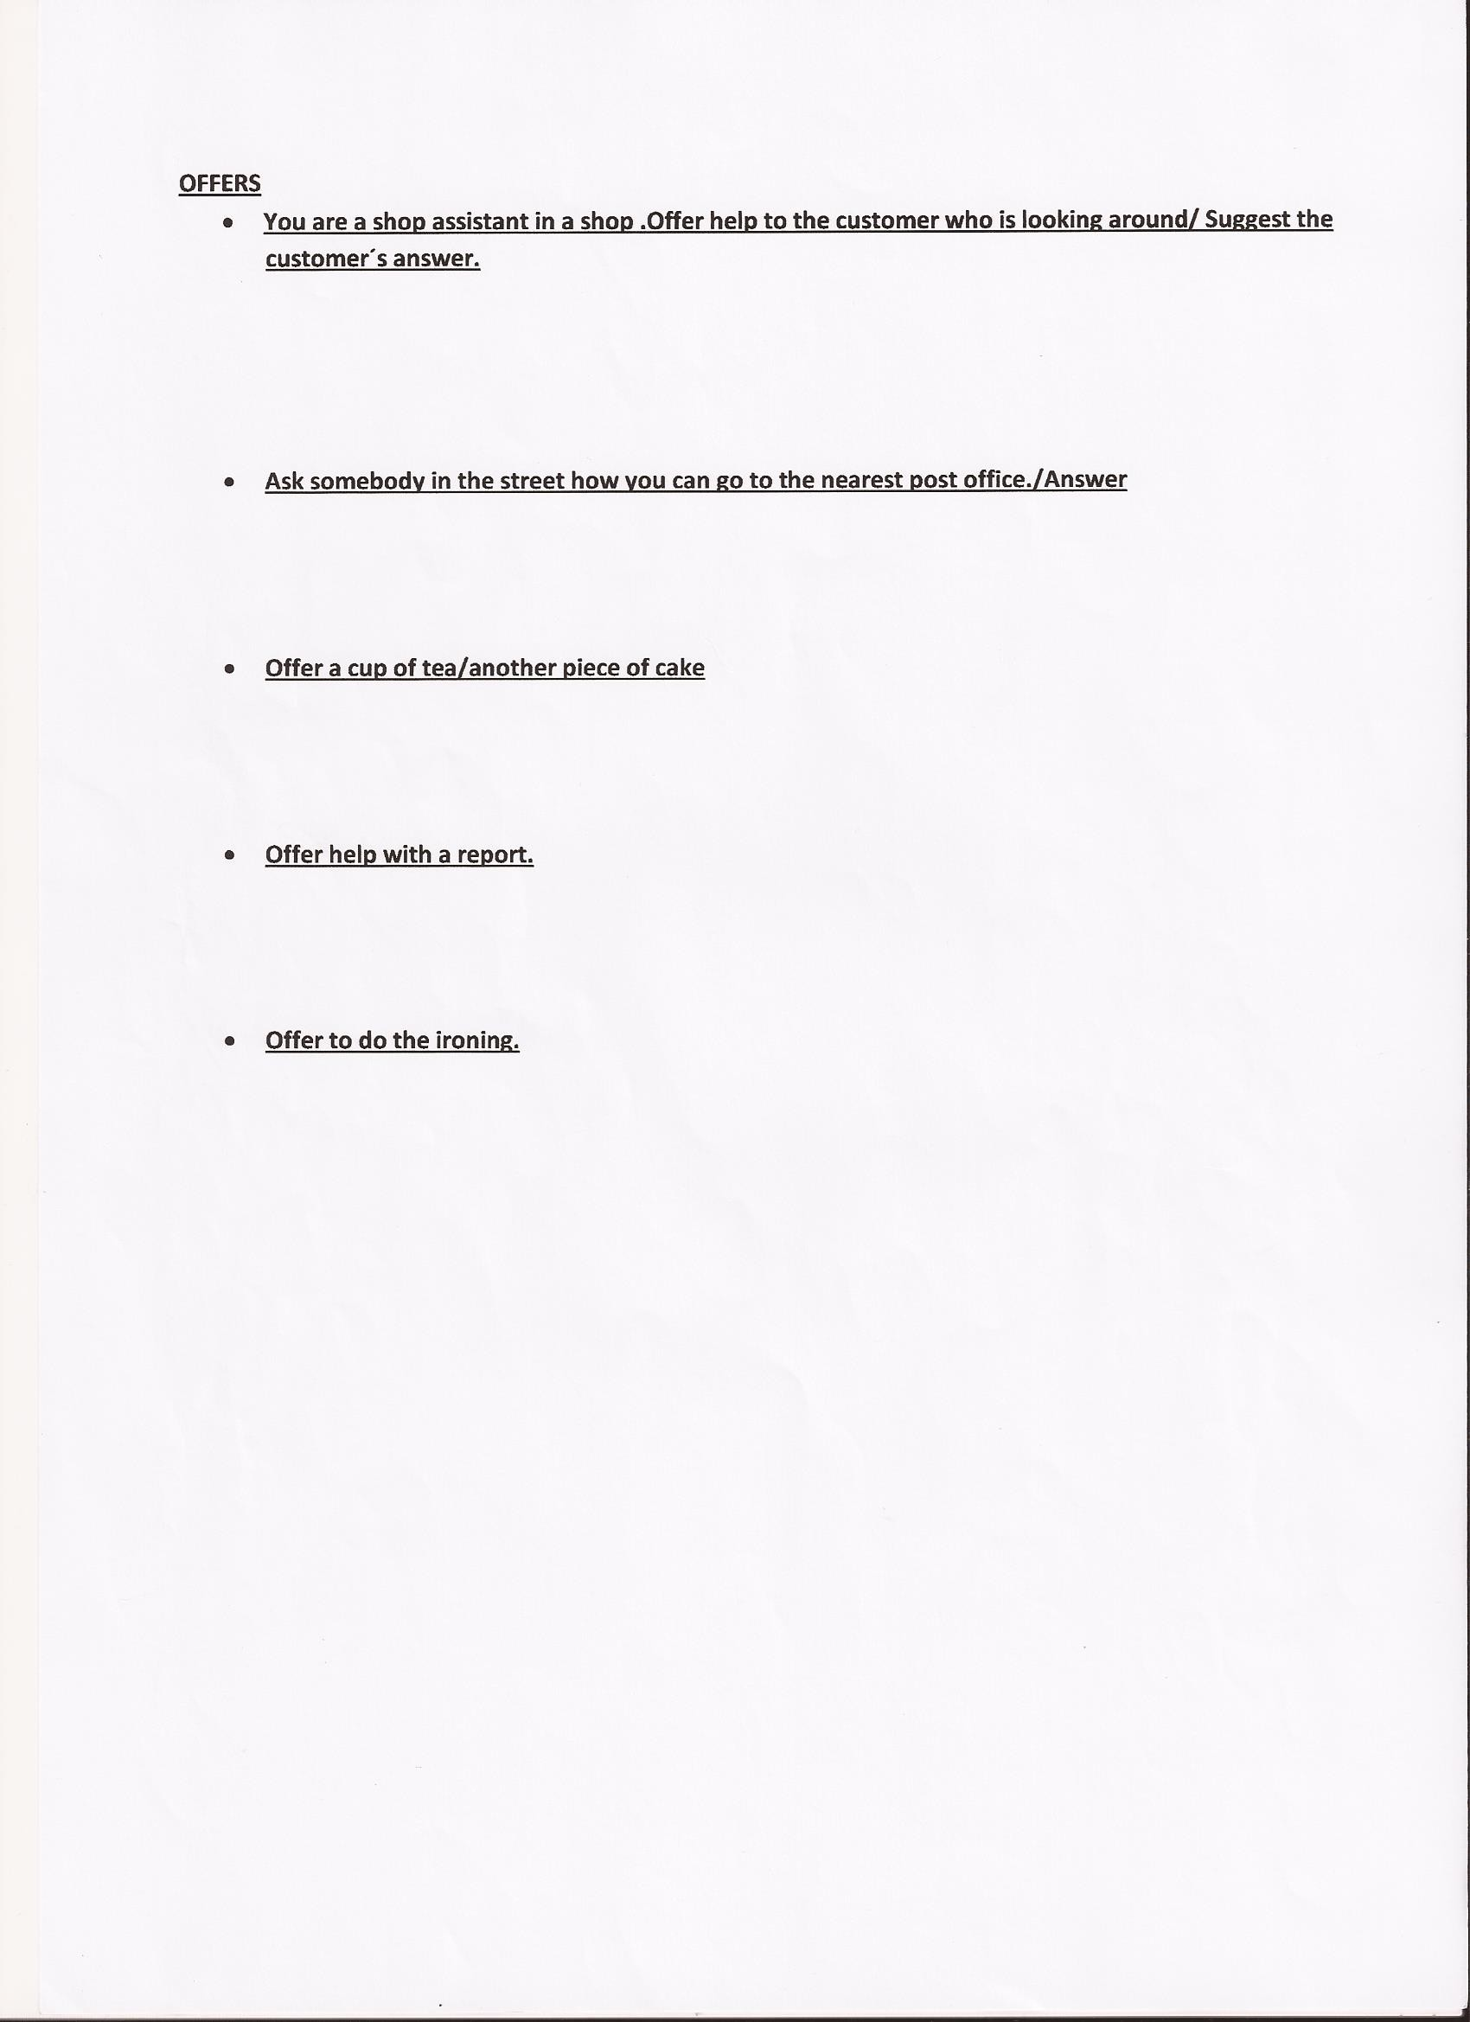

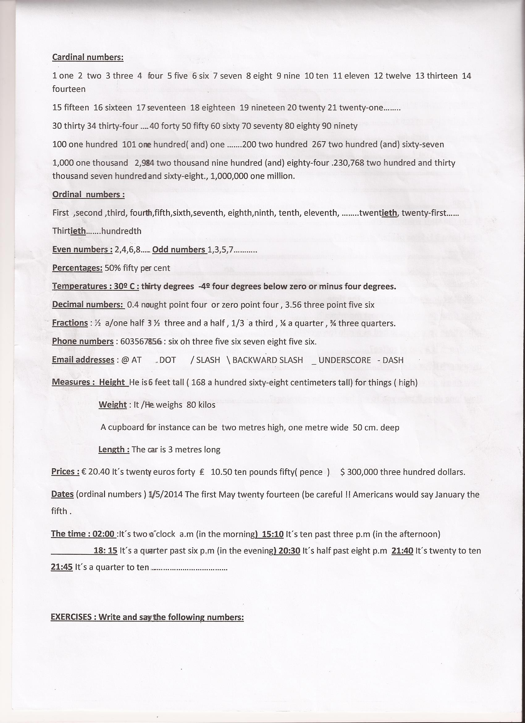

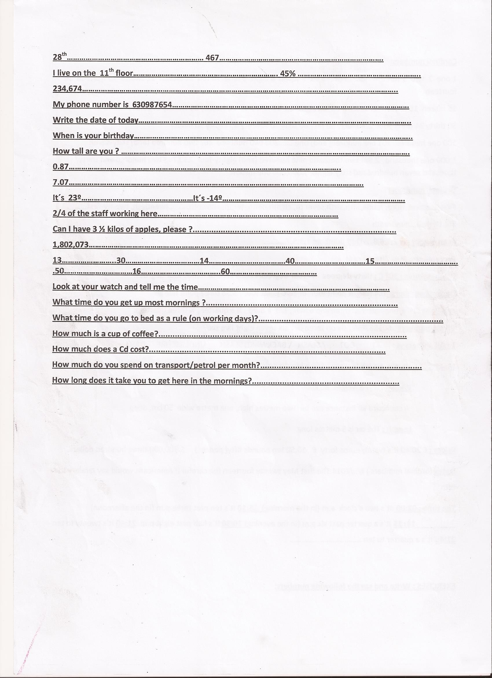

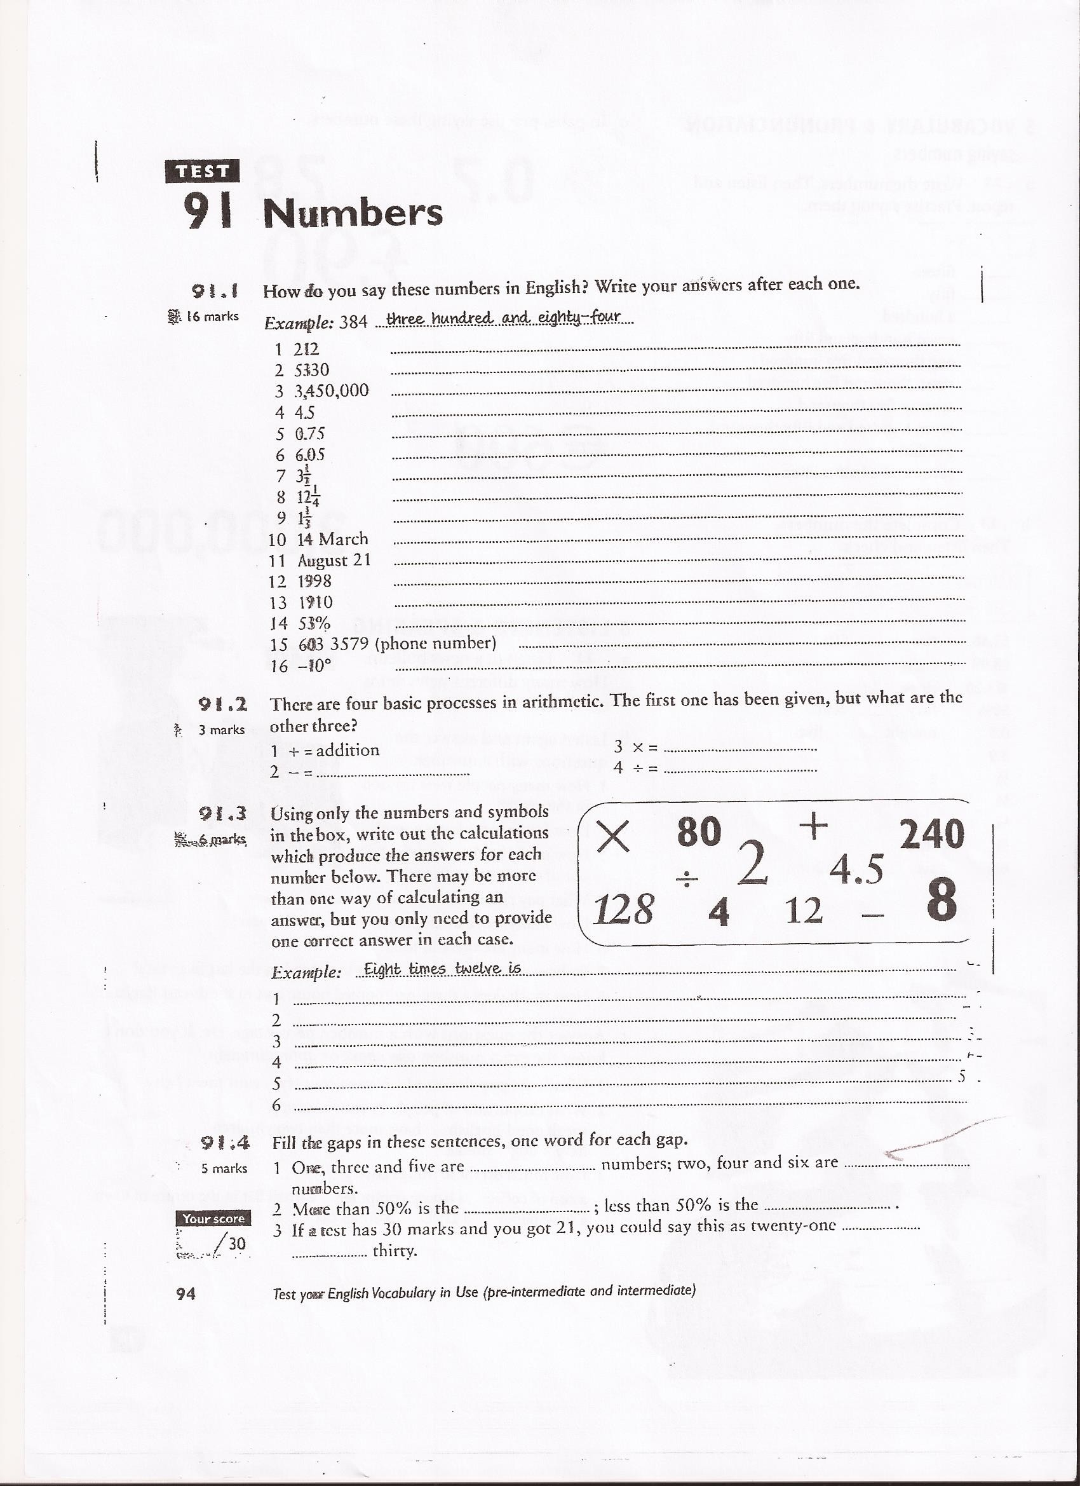

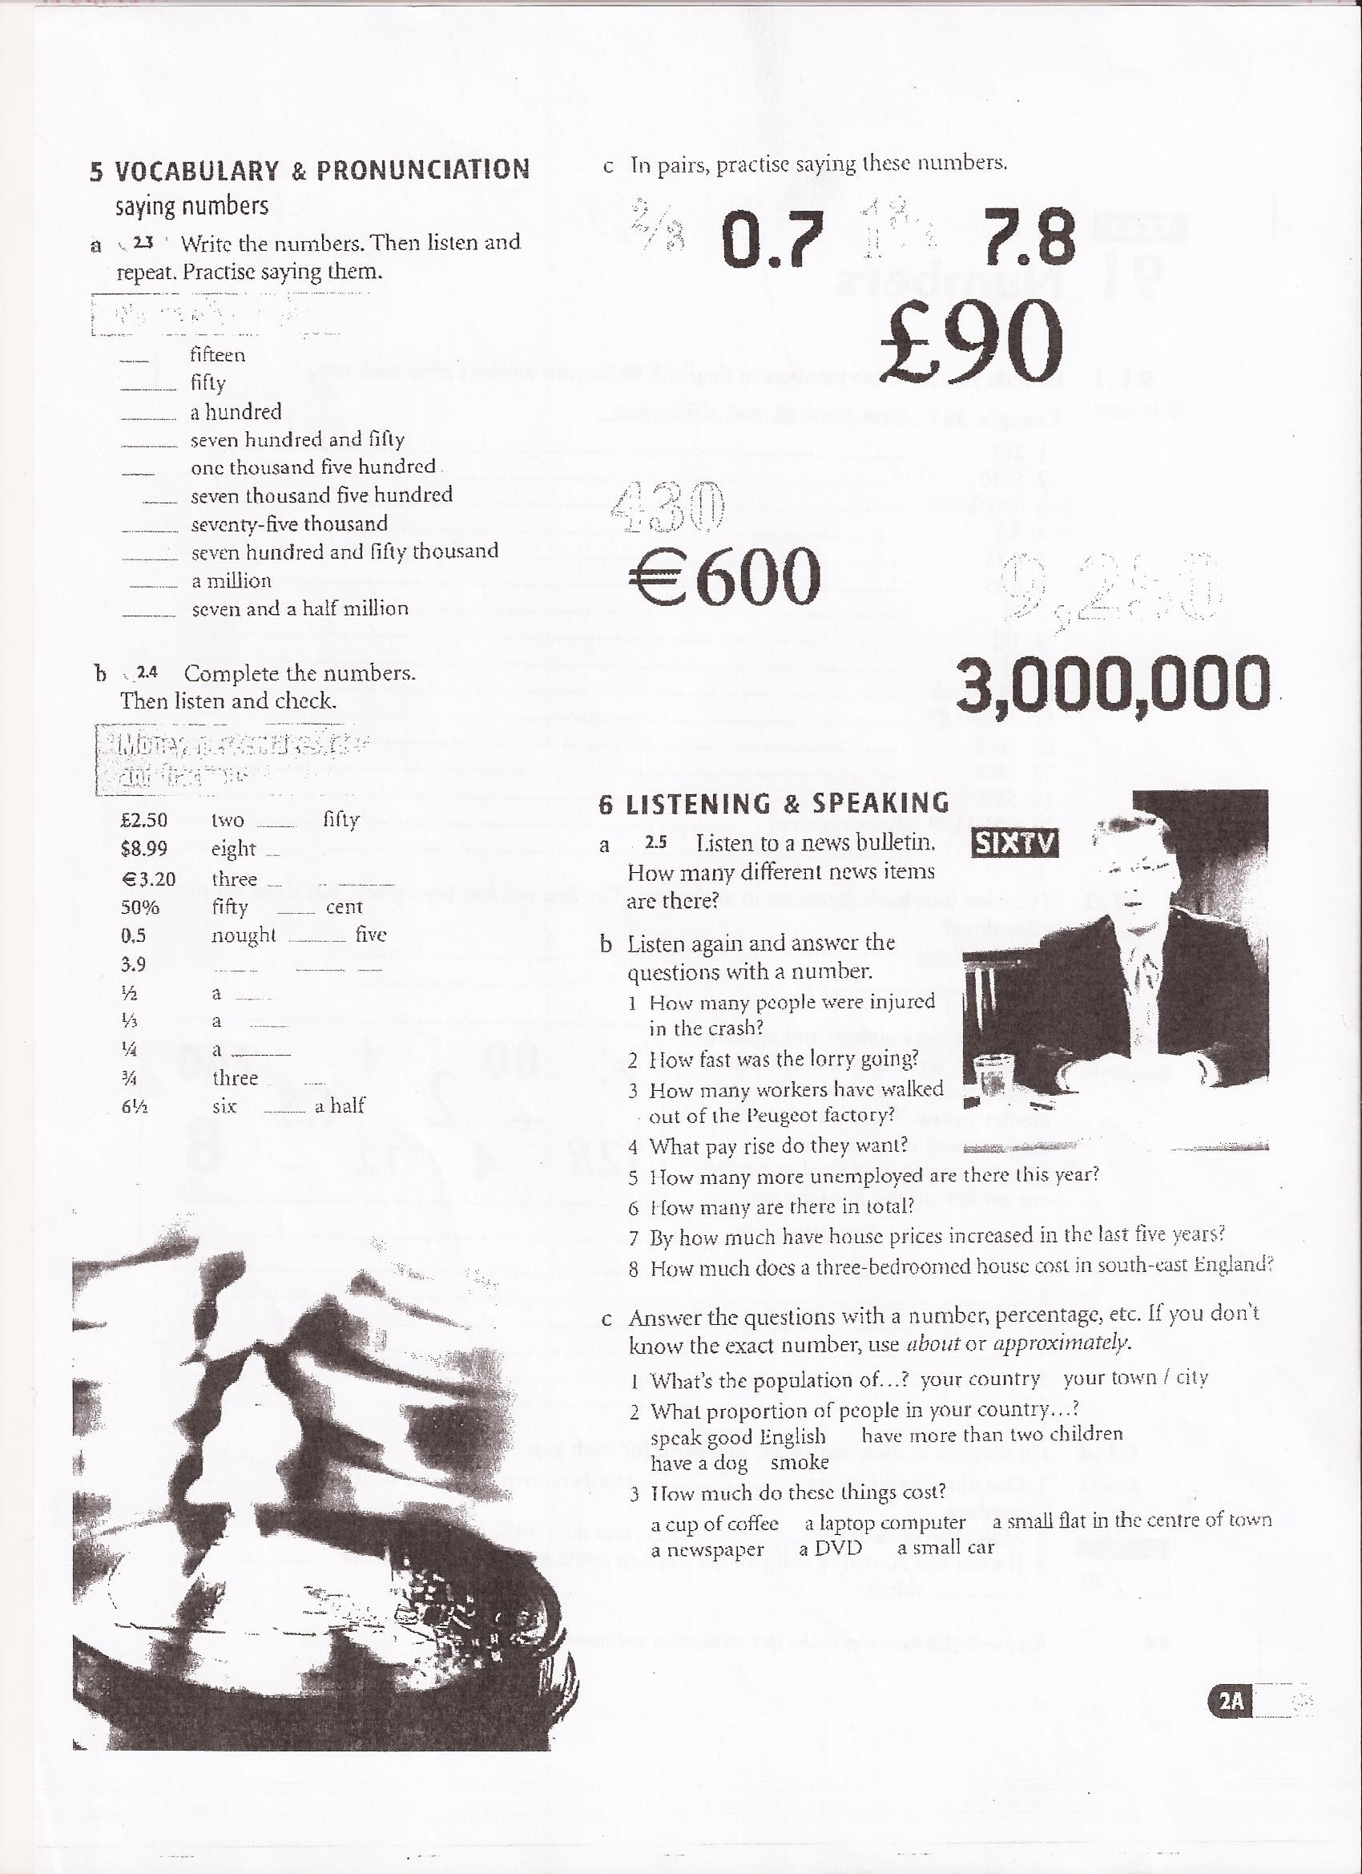

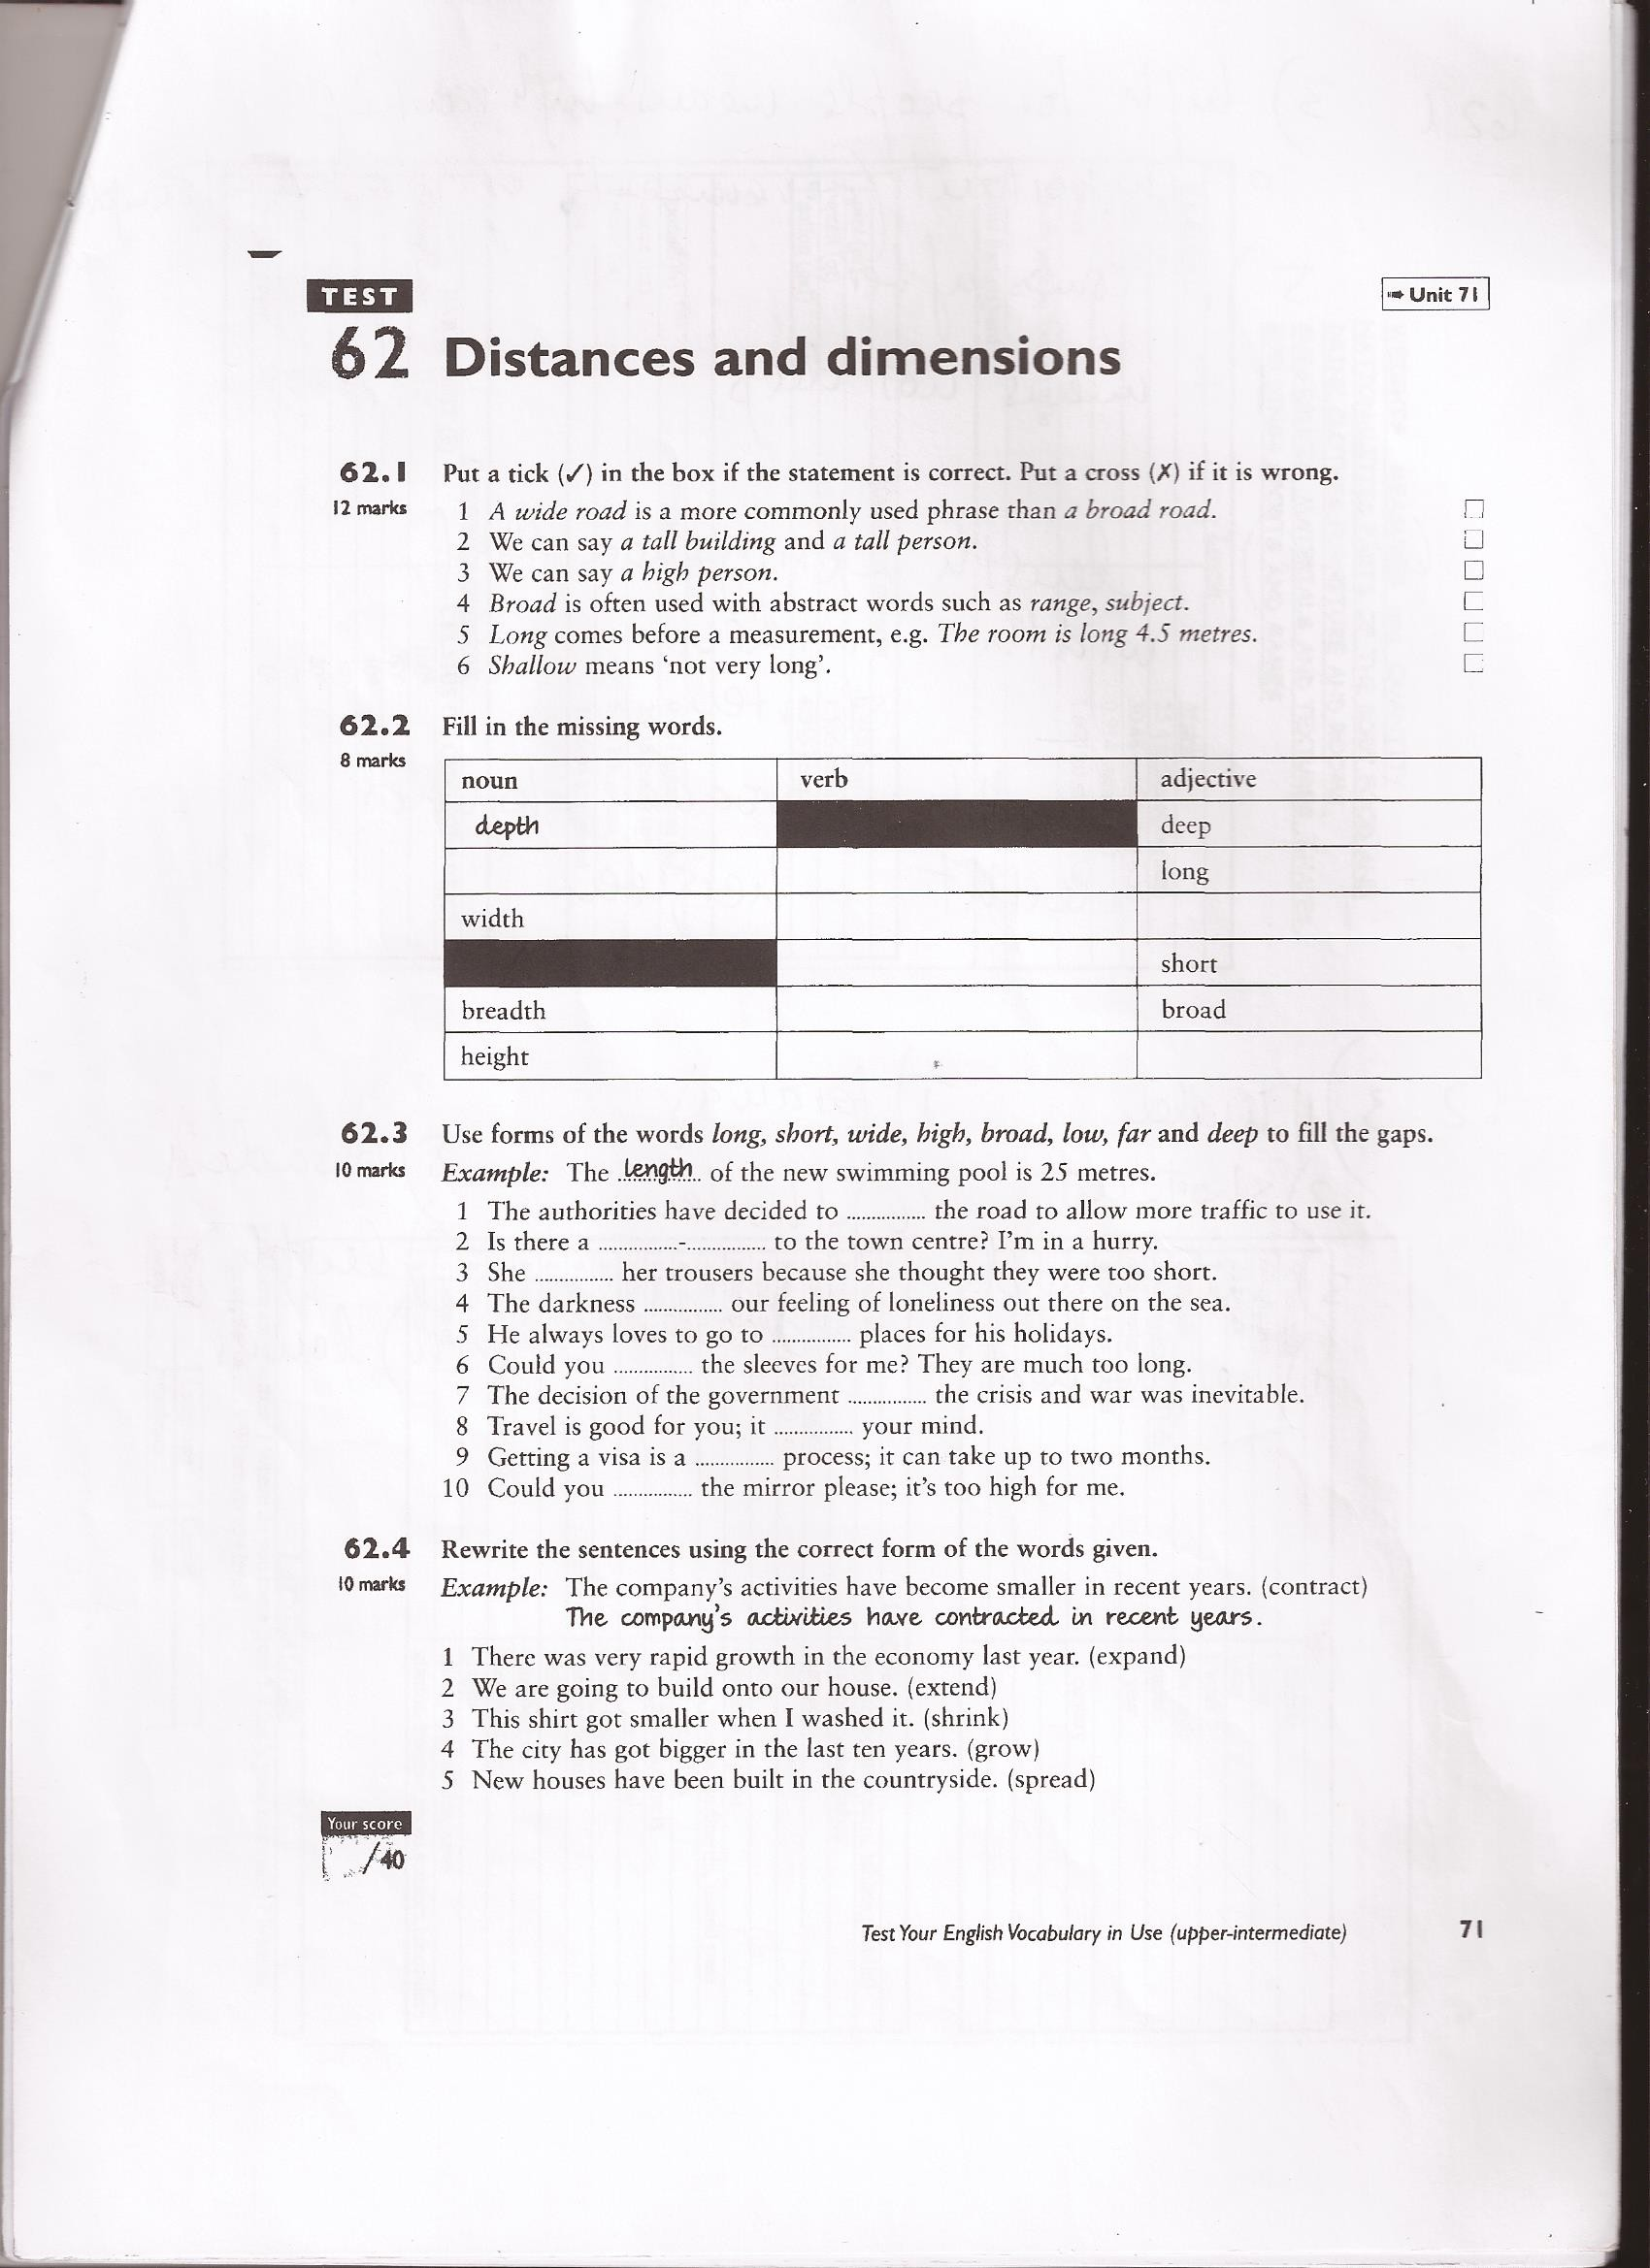

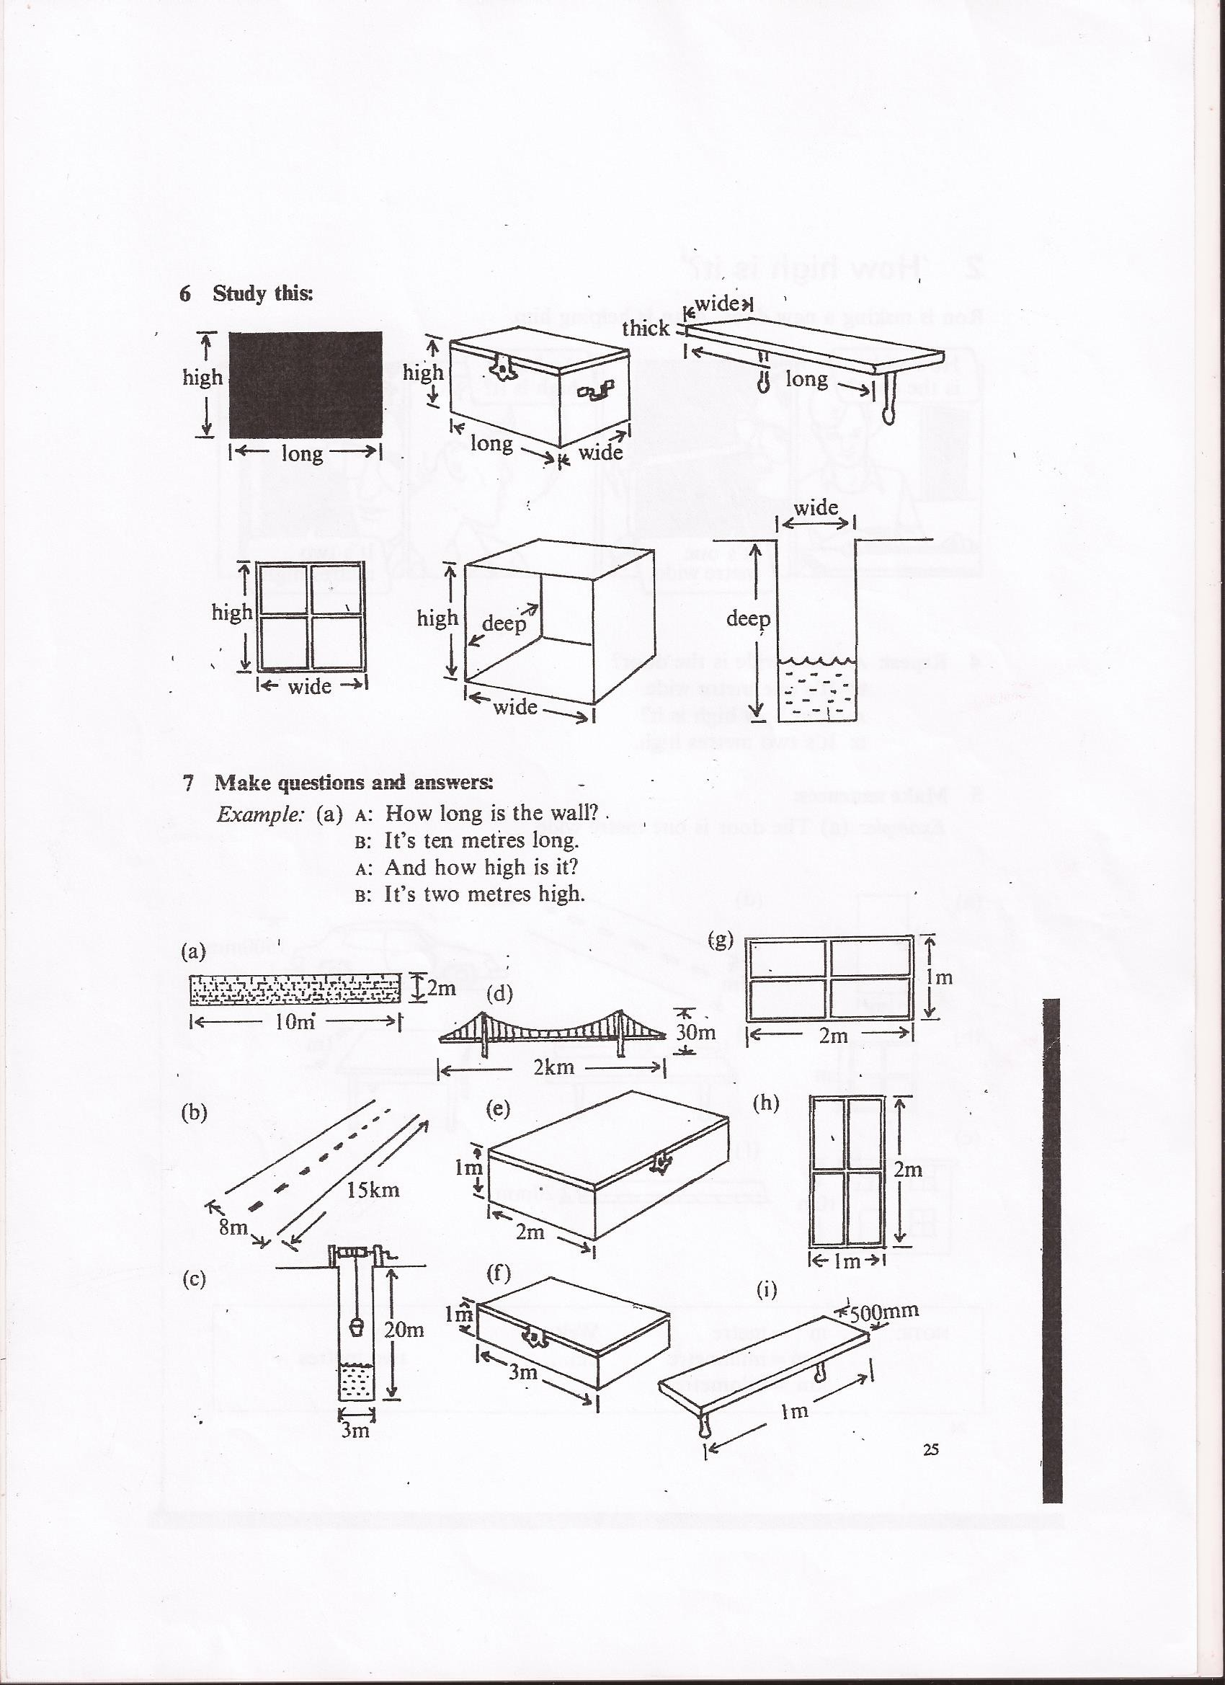

# CAREERS/EMPLOYMENT/COMPANIES

**Career**:a person's progress or general course of action through life or through a phase of life, as in some profession or undertaking.

**University degree**: university studies

**Qualification**:an official record of achievement awarded on the successful completion of a course of training or passing of an exam /a quality, accomplishment, etc., that fits a person for some function, office, or the like./certificates,diplomas .....

**Skills**:the knowledge or ability to do something well**:** Carpentry was one of his many skills.

**STAGES IN A TYPICAL CAREER:** go to school,go to university,do a vocational training course, get qualifications in..... look for and apply for(buscar y solicitar) a job in a company, join a company(incorporarse a una empresa) be hired or employed (ser contratado),move to another company , promote (get better and better jobs),retire(jubilarse)

# COLLOCATIONS (NOUN COMBINATION) WITH THE WORD *CAREERS*

career ladder ----------------------series of levels that lead to better and better jobs

career move ------------------------something you do in order to progress in your job

career break...............................period of time away from your job to, for example look after

your children(take a career break)

career plan --------------------------ideas you have for your future career

careers opportunities--------------chances to start/improve your career

# VOCABULARY (MONEY)

**earn** (not win) a **salary**:a fixed amount of money paid regularly to a person for work (monthly) ganar

**wages**:money that is paid or received for work or services, as by the hour, day, or week.paga semanal o por horas

**fees**:a sum charged or paid, as for professional services for instance to lawyers, plumbers etc:honorarios,tarifas profesionales

**bonus**:something given over and above the normal or expected, esp. a sum of money,

a sum of money granted or given to an employee, a returned soldier, etc., in addition to regular pay, usually in appreciation for work done, length of service, accumulated favours, etc..Extras

it is a gift to reward performance, paid either by a private employer or by a government:

**perks/benefits**:perk (short for perquisite):an additional payment, benefit, or privilege one receives from one's work, beyond income or salary;One of the perquisites is the use of a company car.Beneficios sociales

**unemployment benefit**:an allowance of money paid, usually weekly, to an unemployed worker by a state or federal agency or by the worker's labor union or former employer during all or part of the period of unemployment. Also called unemploy′ment compensa′tion. Informal term : ***dole-*** Paga del paro

**retirement pension:**a pension given to a person who has retired from regular employment, whether paid by the state, arising from the person's former employment, or the product of investment in a personal or stakeholder pension scheme.Pensión de jubilación

**compensation /severance pay:**money paid to a worker being dismissed for reasons beyond the worker's control: Indemnización

# EMPLOYMENT

**part-time/full time job:**employed to work, used, expected to function, etc., less than the usual or full time:a part-time clerk. Trabajo a tiempo parcial/jornada completa

**temporary/permanent job:**a person, employed on a temporary basis,provisionally.Trabajo temporal/fijo

**seasonal job (in tourism )** when you only work in peak season /high season

**clock in /clock out:**to arrive at work,leave work especially when it involves registering the time of arrival on a card-Fichar (entrada y salida del trabajo)

**employee:**a person who has been hired to work for another.Empleado

**employer:**a person or business that employs one or more people, esp. for wages or salary:Empleador,empresario

**self-employed/freelancer:**earning one's living in one's own business or through freelance work, rather than as the employee of another.Autónomo

**unemployed:**not employed;having no job; out of work.Desempleado

**trainee:**a person in training for some job, skill-Becario,en prácticas

**civil servant /state worker:** people working for the state.Civil servants are usually white collar workers (office workers ) and have usualy passed a state exam. Funcionario/ttrabajador estatal

**hire/employ:**to engage the services of a person for wages or other payment:Contratar

**Join:** to become part of a company: Fichar por,incorporarse a

**work on shift:**a person's scheduled period of work, esp. the portion of the day scheduled as a day's work when a shop, service, office, or industry operates continuously during both the day and night:Trabajo por turnos

She prefers the morning shift.

**work overtime/do overtime:** time spent working that is before or after one's regularly scheduled working hours. Horas extra

**work flexitime:**a system that allows an employee to choose the hours for starting and leaving work. Trabajar con horario flexible

**to be at work: (**estar en el trabajo) to be off work (estar ausente) to be out of work(desempleado)

**to be on sick,maternity,paternity leave** : estar de baja por enfermedad, maternidad, paternidad

**get the sack, be sacked, be given the sack,be fired, be out of work**:be out of work .Ser despedido

**to fire, dismiss,give the sack, let somebody go:**despedir

**be made redundant**:You can be fired for a number of reasons, but "being made redundant" suggests that the company simply no longer has any need for you.(implica recortes de plantilla)

**Redundancies or downsizing** :reduce the staff :recortes de plantilla

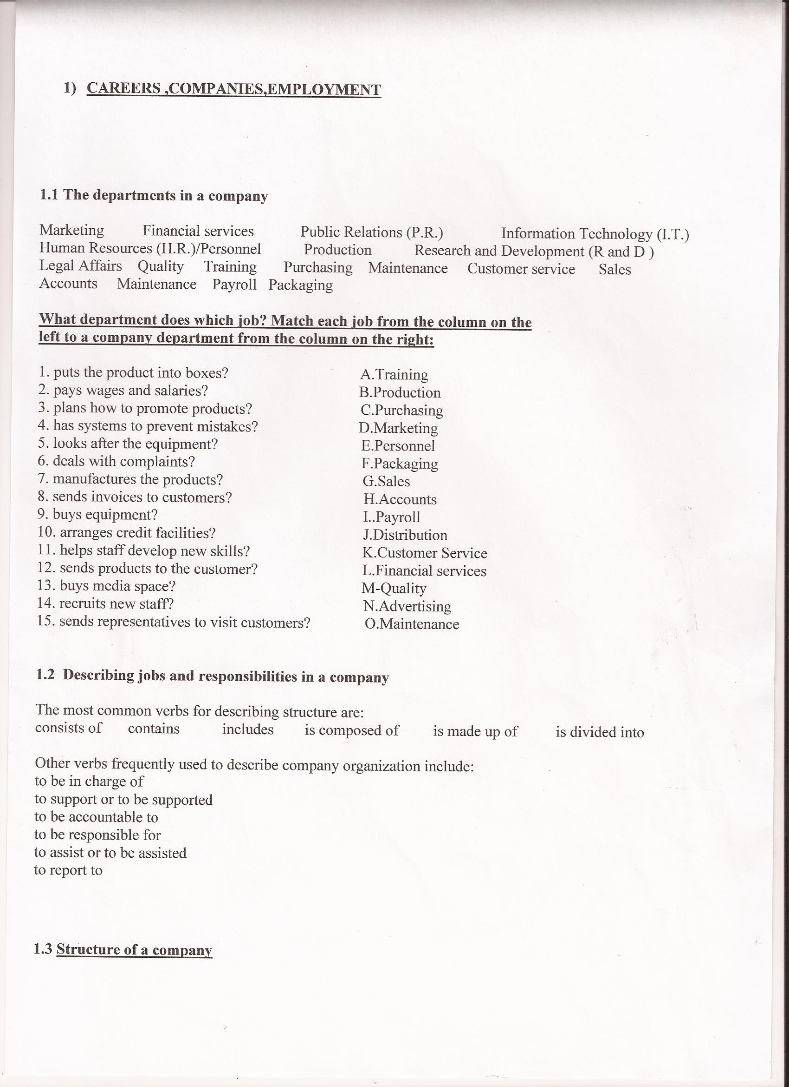

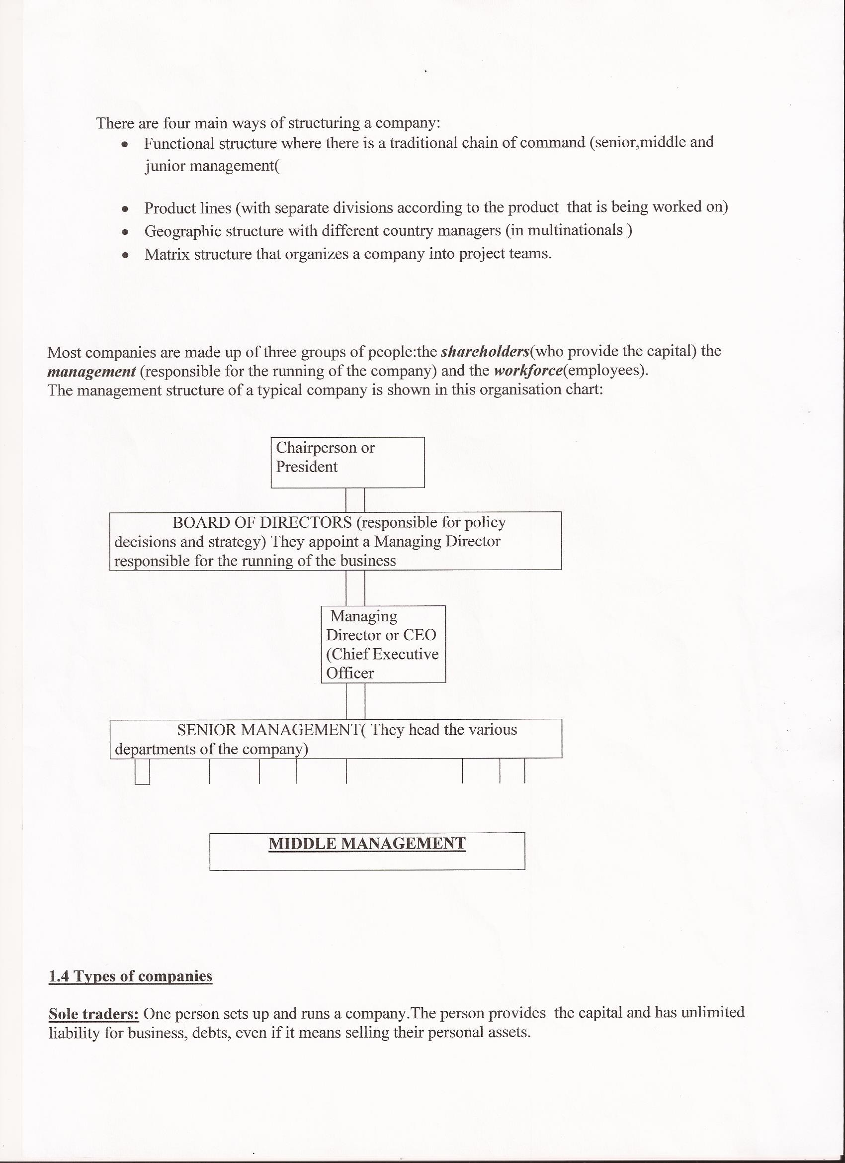

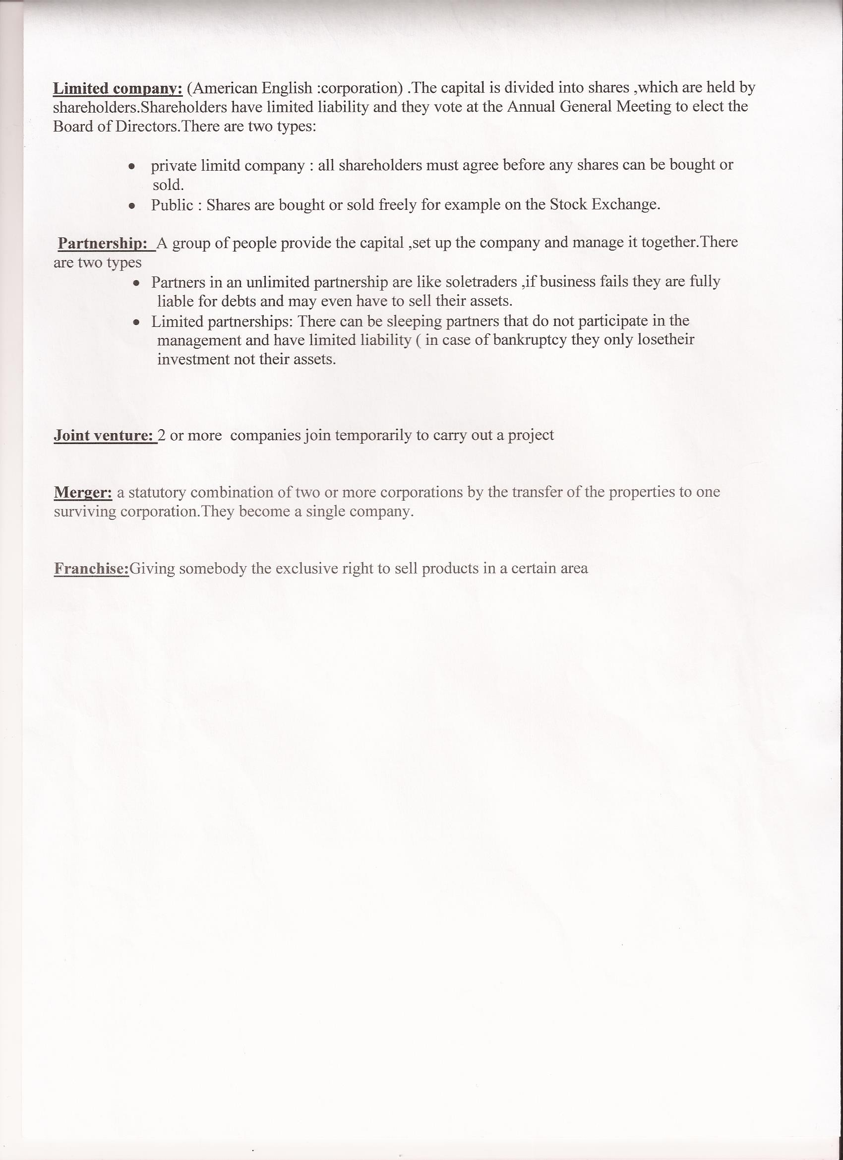

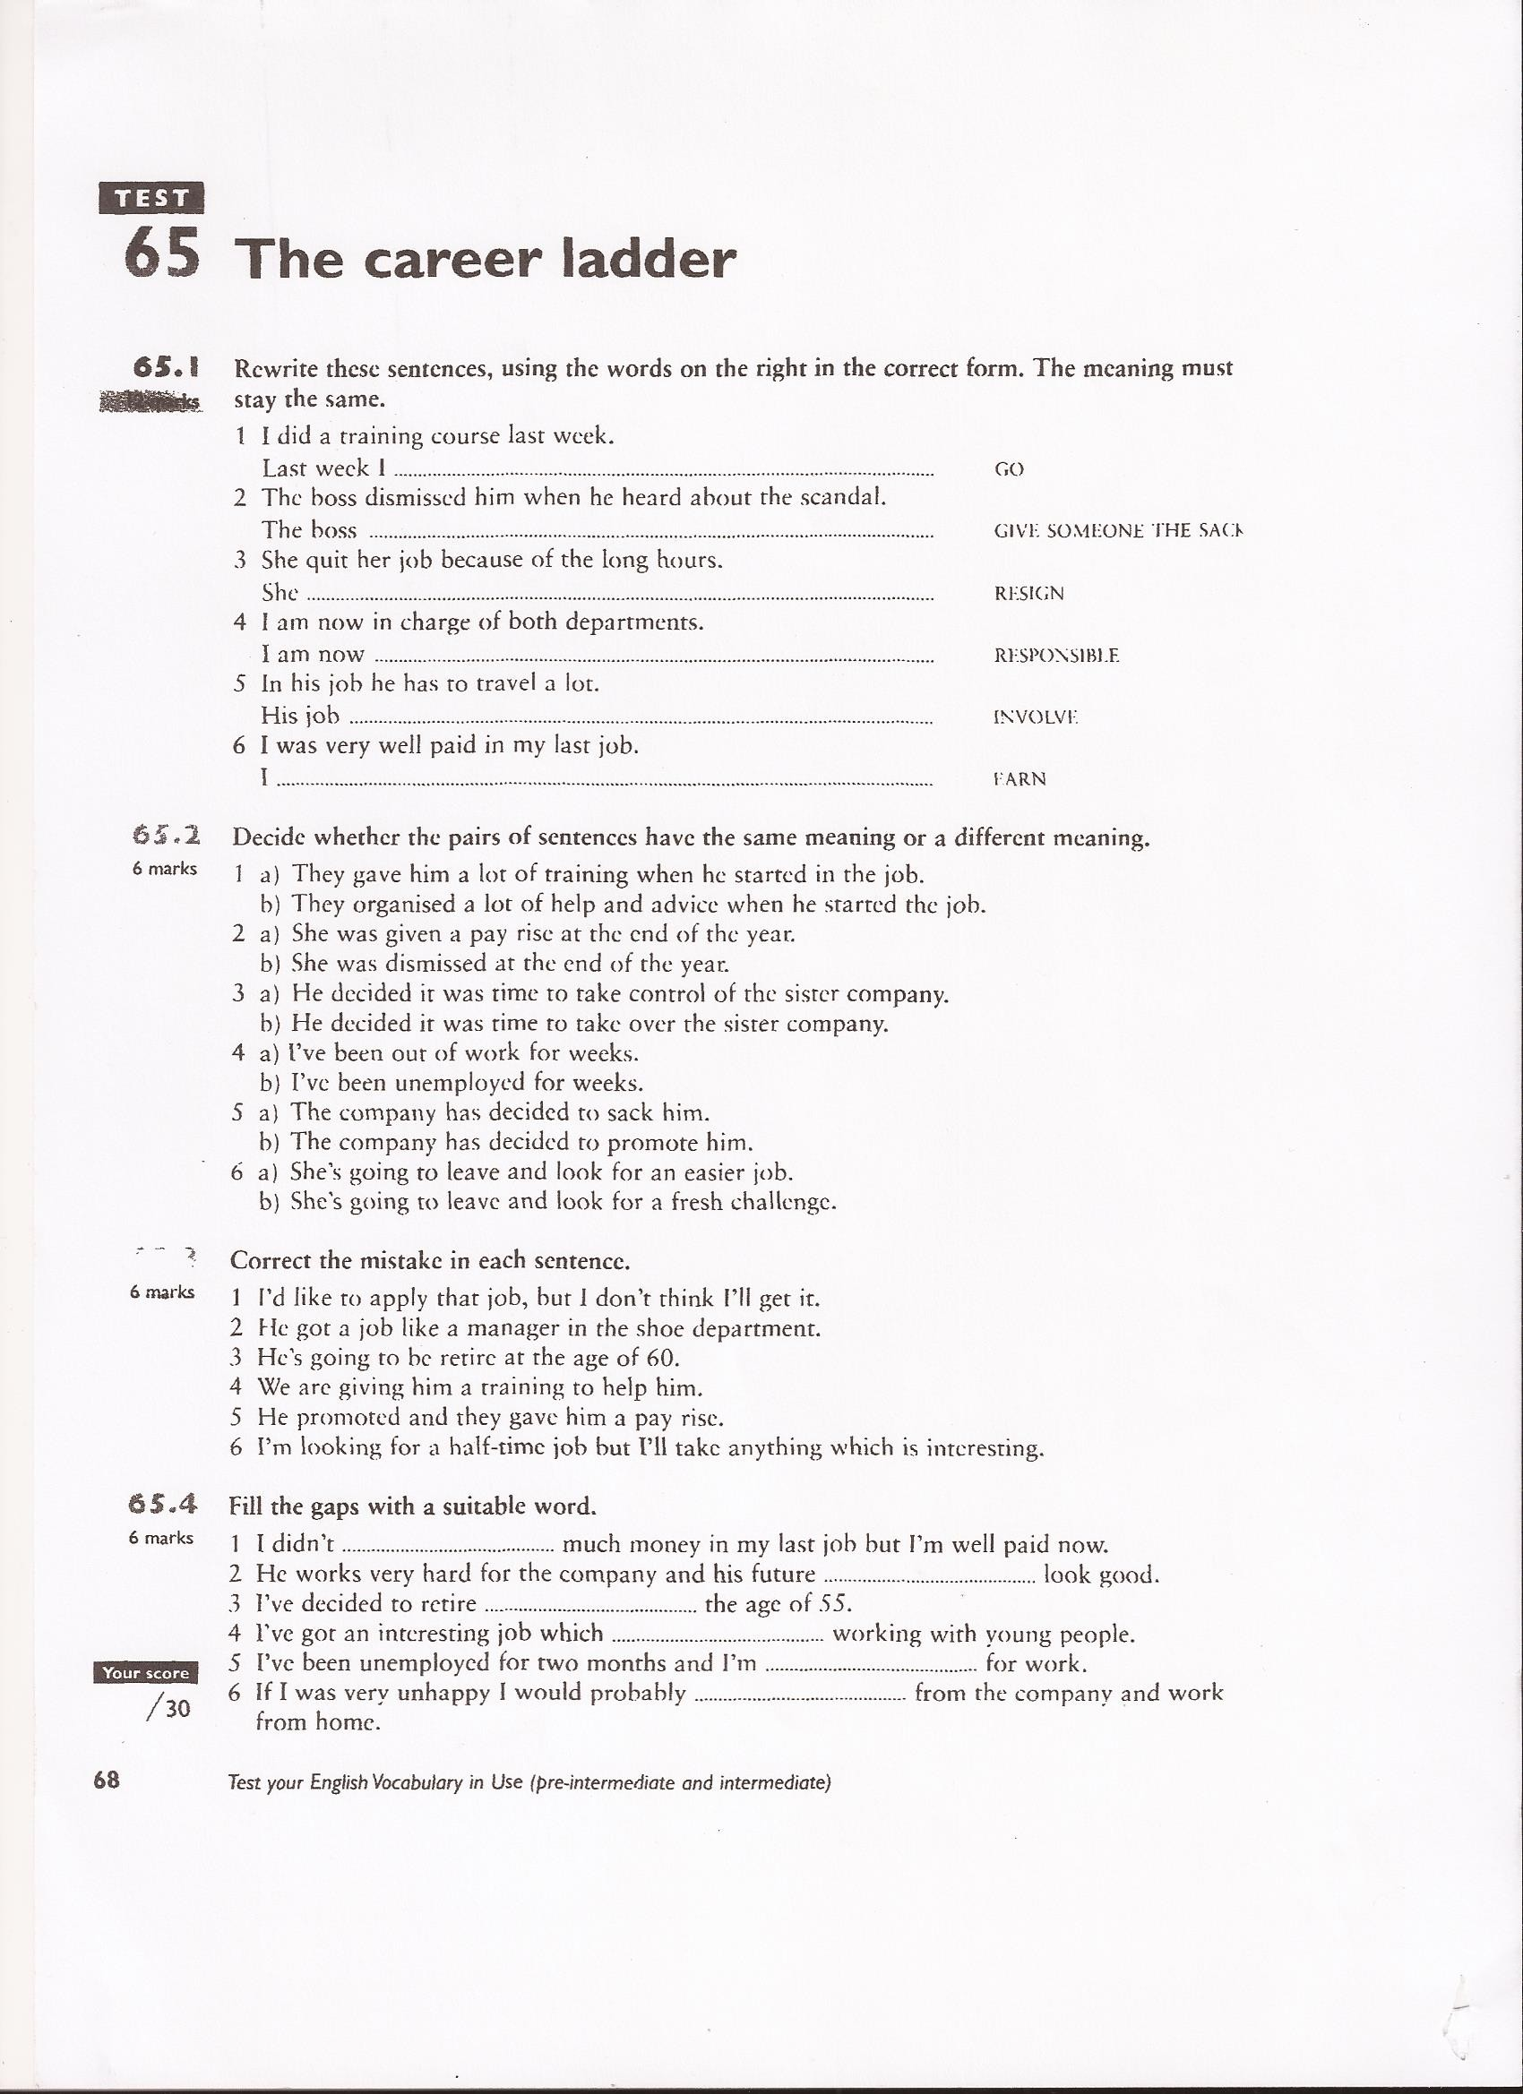

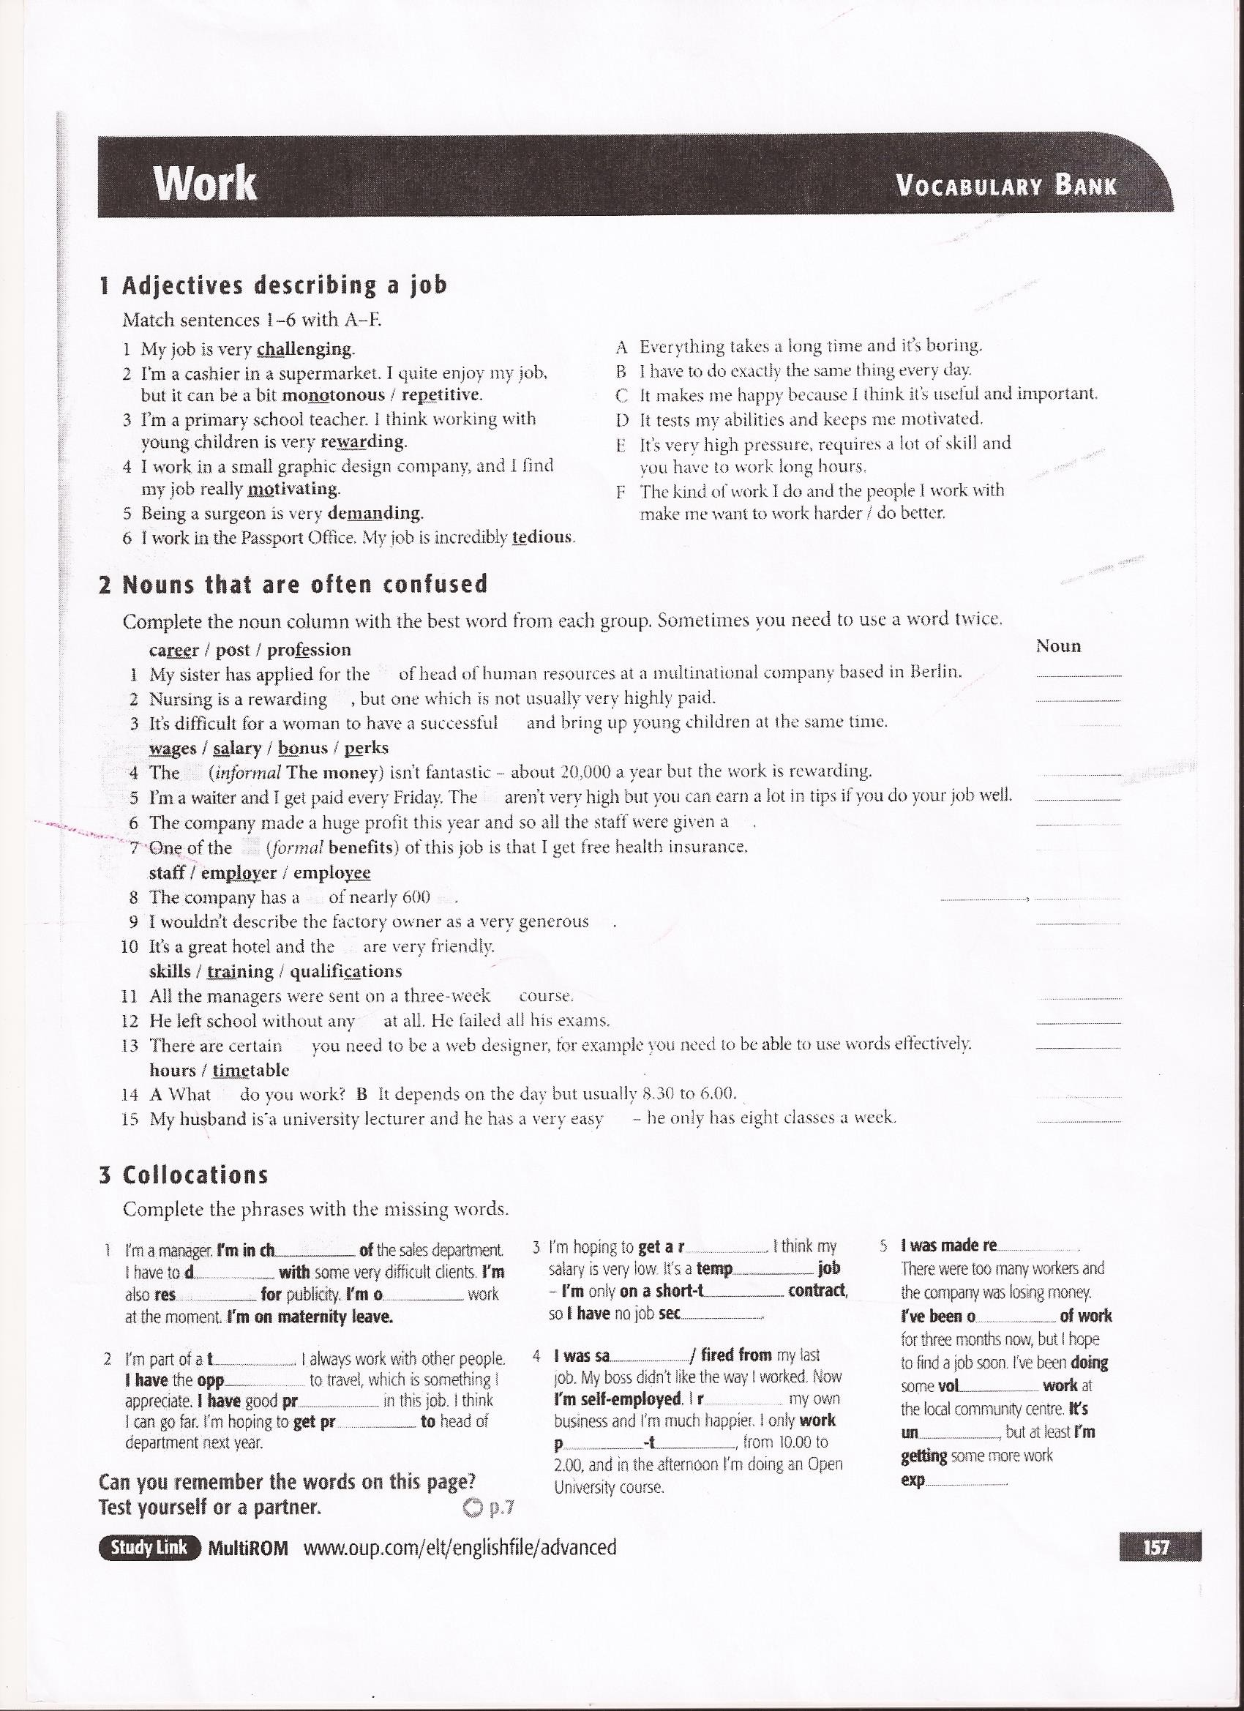

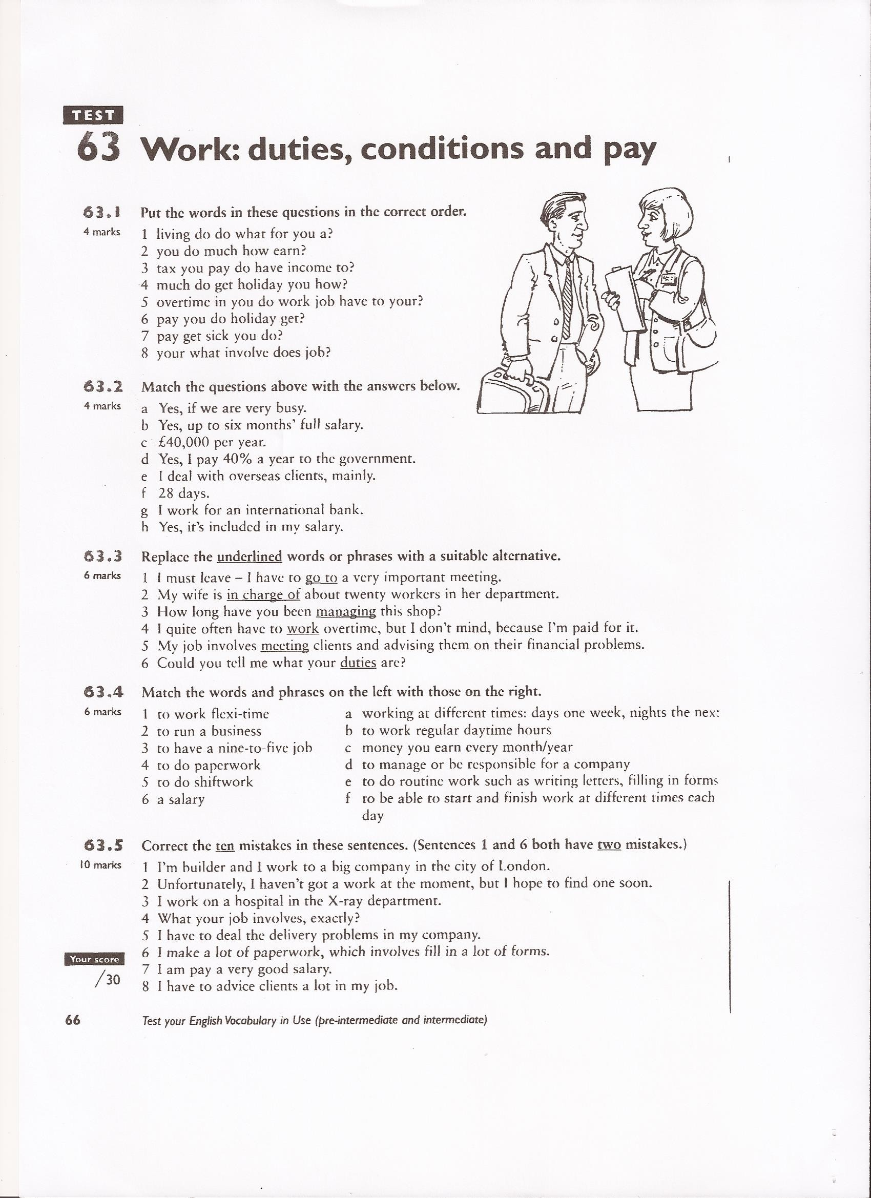

# JOB INTERVIEWS

# TIPS FOR JOB INTERVIEWS SUCCESS

1. First impressions count. Greet your interviewer with a smile and a firm handshake. Give eye contact
2. Be prepared. Re-read your CV and the job offer just before the interview. Do research: Look at the company website or ask for information.
3. Answer questions fully, sticking to the point.
4. Why should they hire you? Most job adverts will list qualities and skills they are looking for –a team worker, a good communicator- so, you should think of examples of how you can demonstrate these skills. Be ready to talk about your knowledge, experience, abilities and skills. Have at least three strong points about yourself you can relate to the company and job on offer.
5. Be prepared to talk about one weakness, but perhaps one that is not important or relevant for the job you are applying for.
6. Be positive. Interviewers like to see someone who is enthusiastic and enjoys a challenge.
7. Remember your body language: It´s not what you say but how you say it .During the interview do not fold your arms

# FREQUENT QUESTIONS IN A JOB INTERVIEW

* What is your greatest weakness?
* What is your greatest strength?
* Tell me about yourself
* Tell something that is not in your CV
* How do you handle failure?
* How do you see yourself in five years ‘time?
* How does this job fit in your career plan?
* How do you handle stress?
* Are you good at working under pressure?
* Are you willing to move abroad if required?
* What motivates you?
* What strategies would you use to motivate your team?
* Why should we hire you?
* Are you a good team-player?
* What have you learnt from your mistakes?
* What did you like or dislike about your previous job?
* Why did you leave your previous job?
* What do you know about us?
* Why do you want this job?
* What can you do for this company?
* Are you willing to travel /to work at weekends?
* What are your goals for the next five years?
* When could you start work?
* Describe your ideal boss

|  |  |  |
| --- | --- | --- |
| Types of strength | Examples | Sample answers |
| Job-specific | * Computer skills * Technical training * Product/industry knowledge | “One of my greatest strengths is my proficiency with Excel. I have wide experience with the program |
| Transferable | * Proficient in a language * Written or oral communication skills * Problem solving | “I have often been praised for my ability to come up with solutions to problems facing my team or work group |
| Personal characteristics | * Punctual * Self-motivated * Adaptable * confident | “I am excellent at adapting to changes and becoming comfortable in new settings. |

|  |  |  |
| --- | --- | --- |
| Types of weaknesses | Examples | Sample answers |
| Those unrelated to the position | * fear of speaking in public if the job doesn´t require it * lack of computer skills if the job doesn´t require it | “I have learnt through other jobs that I´m not a good salesman. That´s one of the reasons I´m looking forward to the potential to change careers |
| Those that can be turned into positive | * lack of attention to detail as a result of seeing too much of the big picture * difficulty multi-tasking, due to an intense focus on the task at hand | “Because I concentrate so much on what I´m doing, I often have a hard time dealing with interruptions…… |
| Those that you´re working to improve | * learning to delegate * spelling | “I´m such a perfectionist by nature that I sometimes spend much more time on tasks than necessary. As a result, I´ve learnt to keep a large clock on my desk. By giving myself small deadlines all day, I make sure I don´t waste too much time. |

# POPULAR SKILLS THAT EMPLOYERS WANT

* Effective communication. Candidates that can listen to instructions, who speak, write and listen effectively, organize their thoughts logically and explain everything clearly
* Computer and technical skills
* Problem-solving and creativity
* Interpersonal abilities: A candidate should be good at relating to others, both co-workers and customers
* Teamwork skills
* Diversity sensitivity: In today´s world, cultural sensitivity and ability to build rapport with others in a multicultural environment is highly valued by employers.
* Planning and organizing
* Leadership and management

# PERSONAL QUALITIES

* Adaptability and flexibility. Almost half of employers in a recent survey gave a high rating to “openness to new ideas and concepts”
* Professionalism and work ethic: Employers seek productive workers with positive work ethics who stick with challenges until they meet them.
* Positive attitude and energy: The last to be picked and promoted are candidates who show gloomy outlooks and emotional immaturity. Exhibit energetic, organized behavior.
* Honesty
* Employers want accurate and timely information regarding their business and their employees. Made a mistake? Don’t cover it up, admit it, and learn not to do it again.
* Determination and Persistence
* Managers will give employees challenging goals but generally they are achievable. The key is to be able to work hard and keep moving forward when you encounter obstacles.
* Loyalty
* Employers want and need to be able to trust their employees to work professionally to meet the employer’s best interests. Employers do not want to hire people who require close scrutiny or who cannot be trusted to represent the company in public.

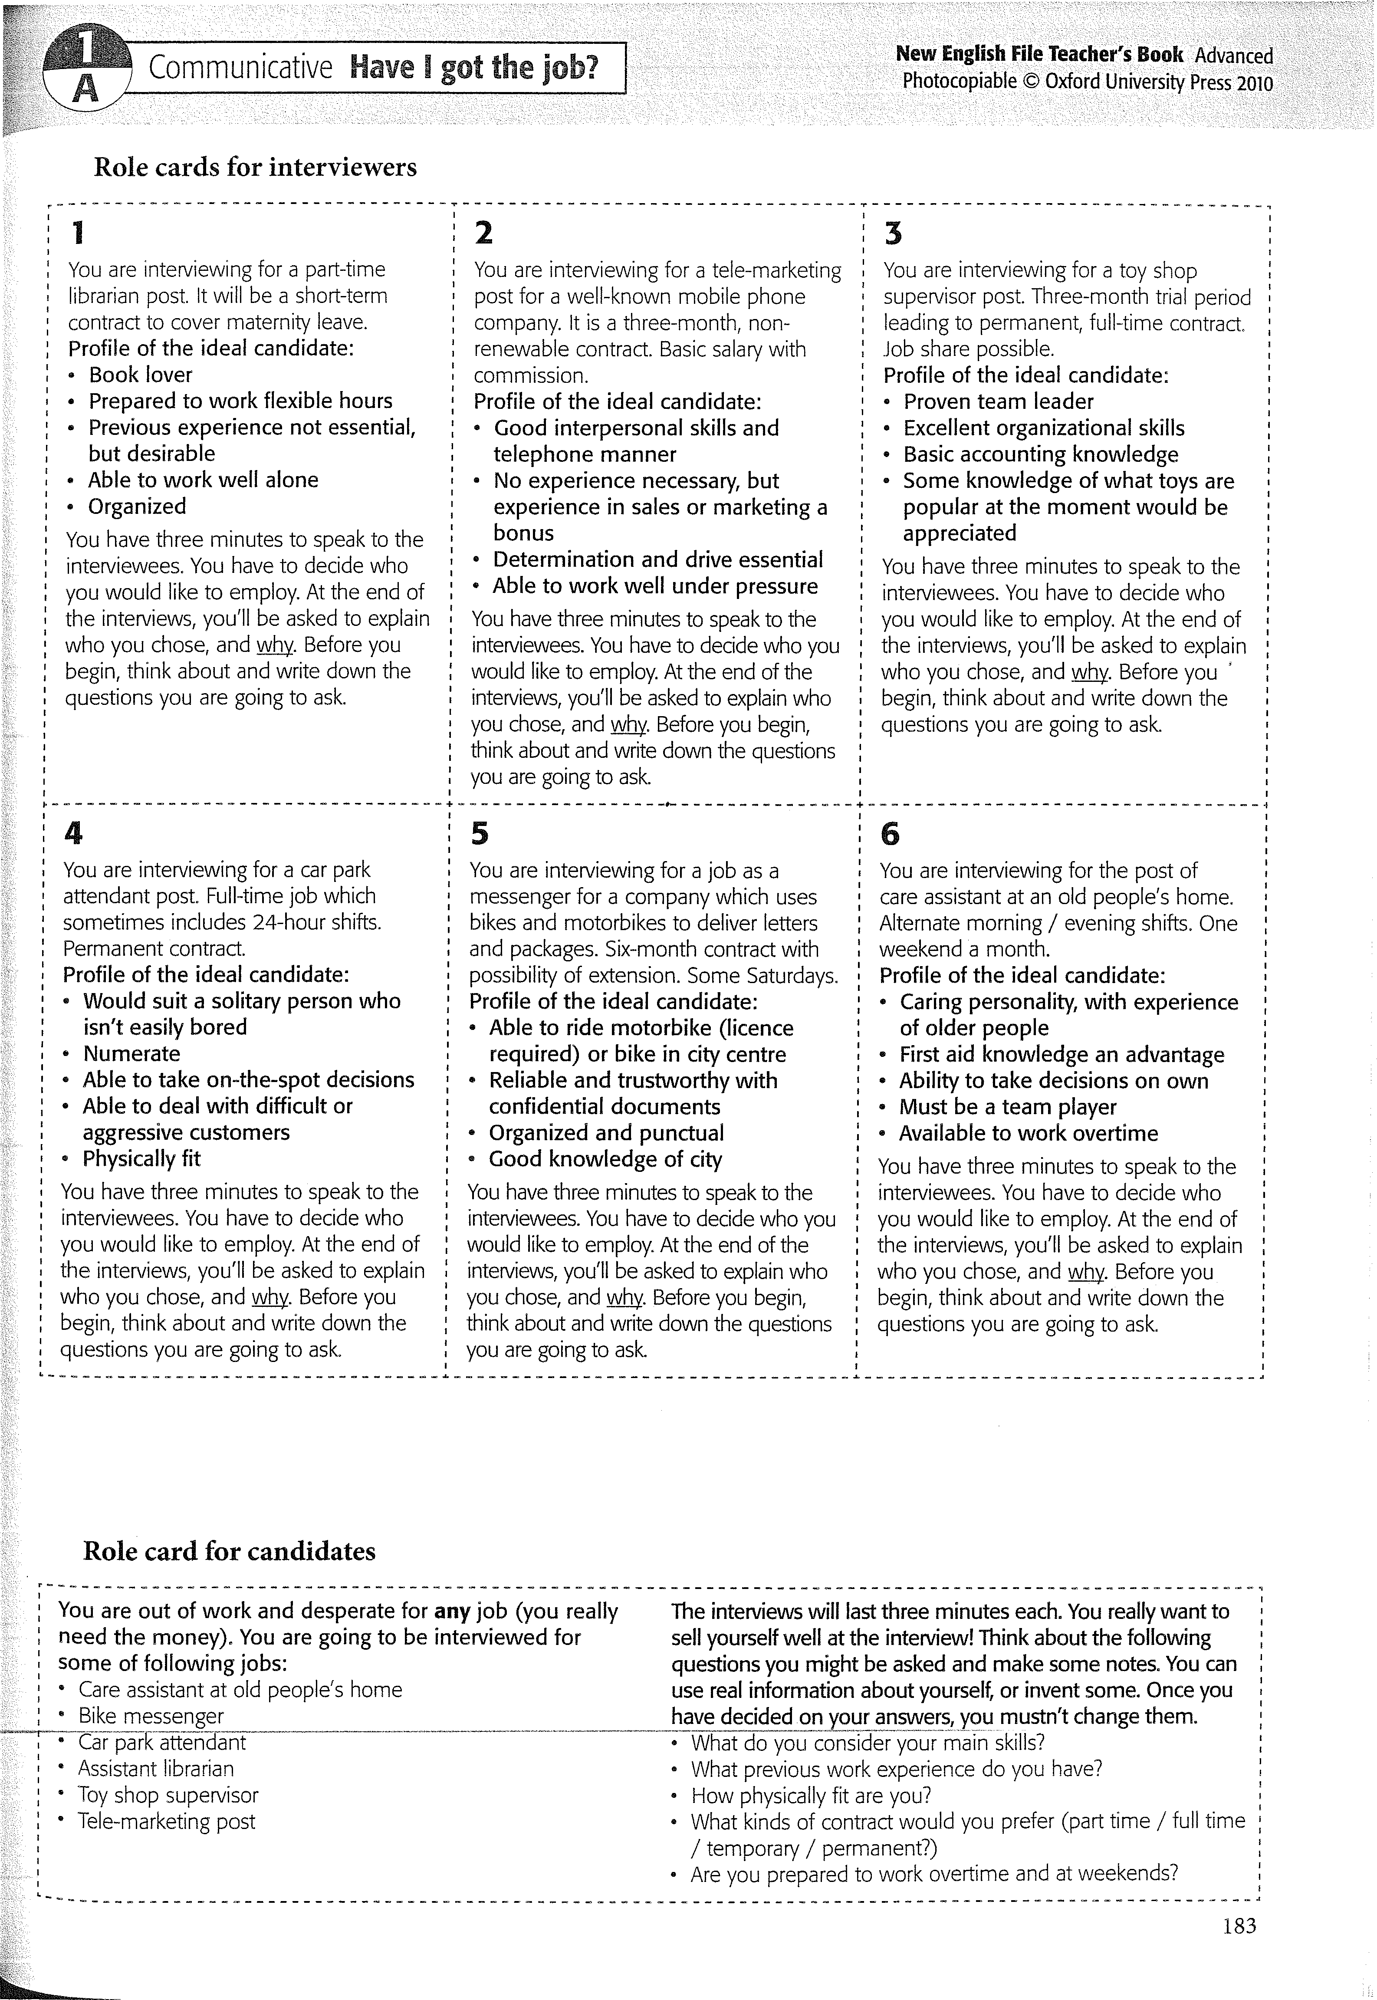

# NOUN SUFFIXES

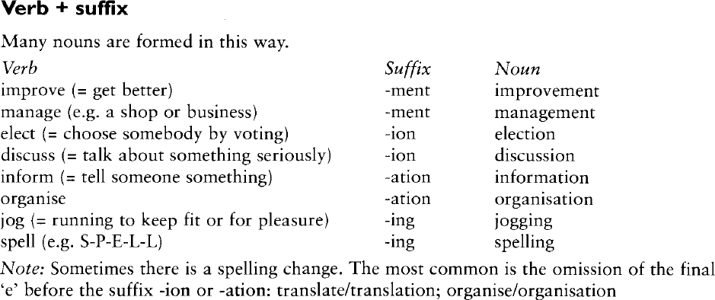

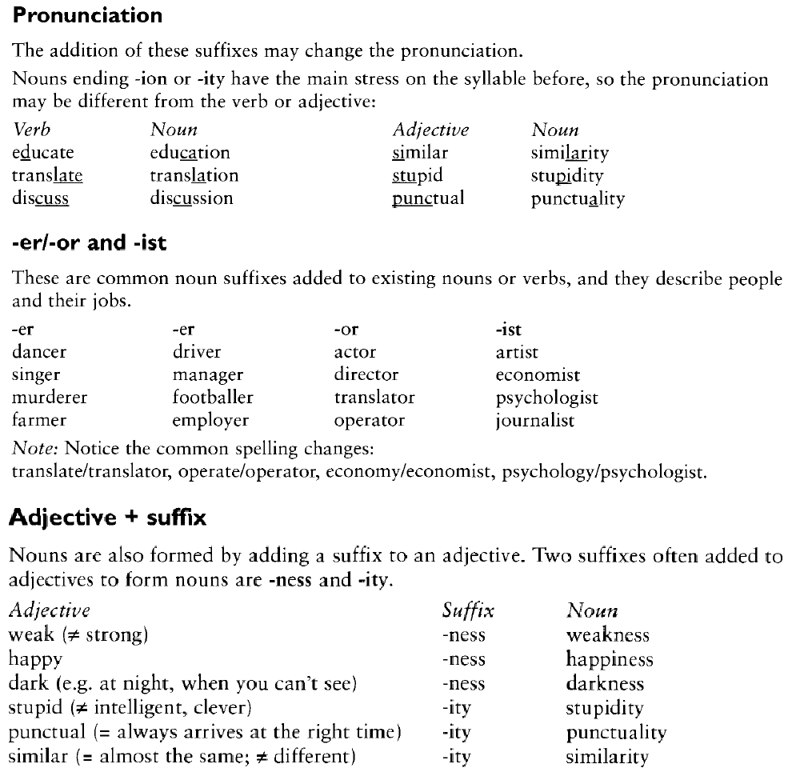

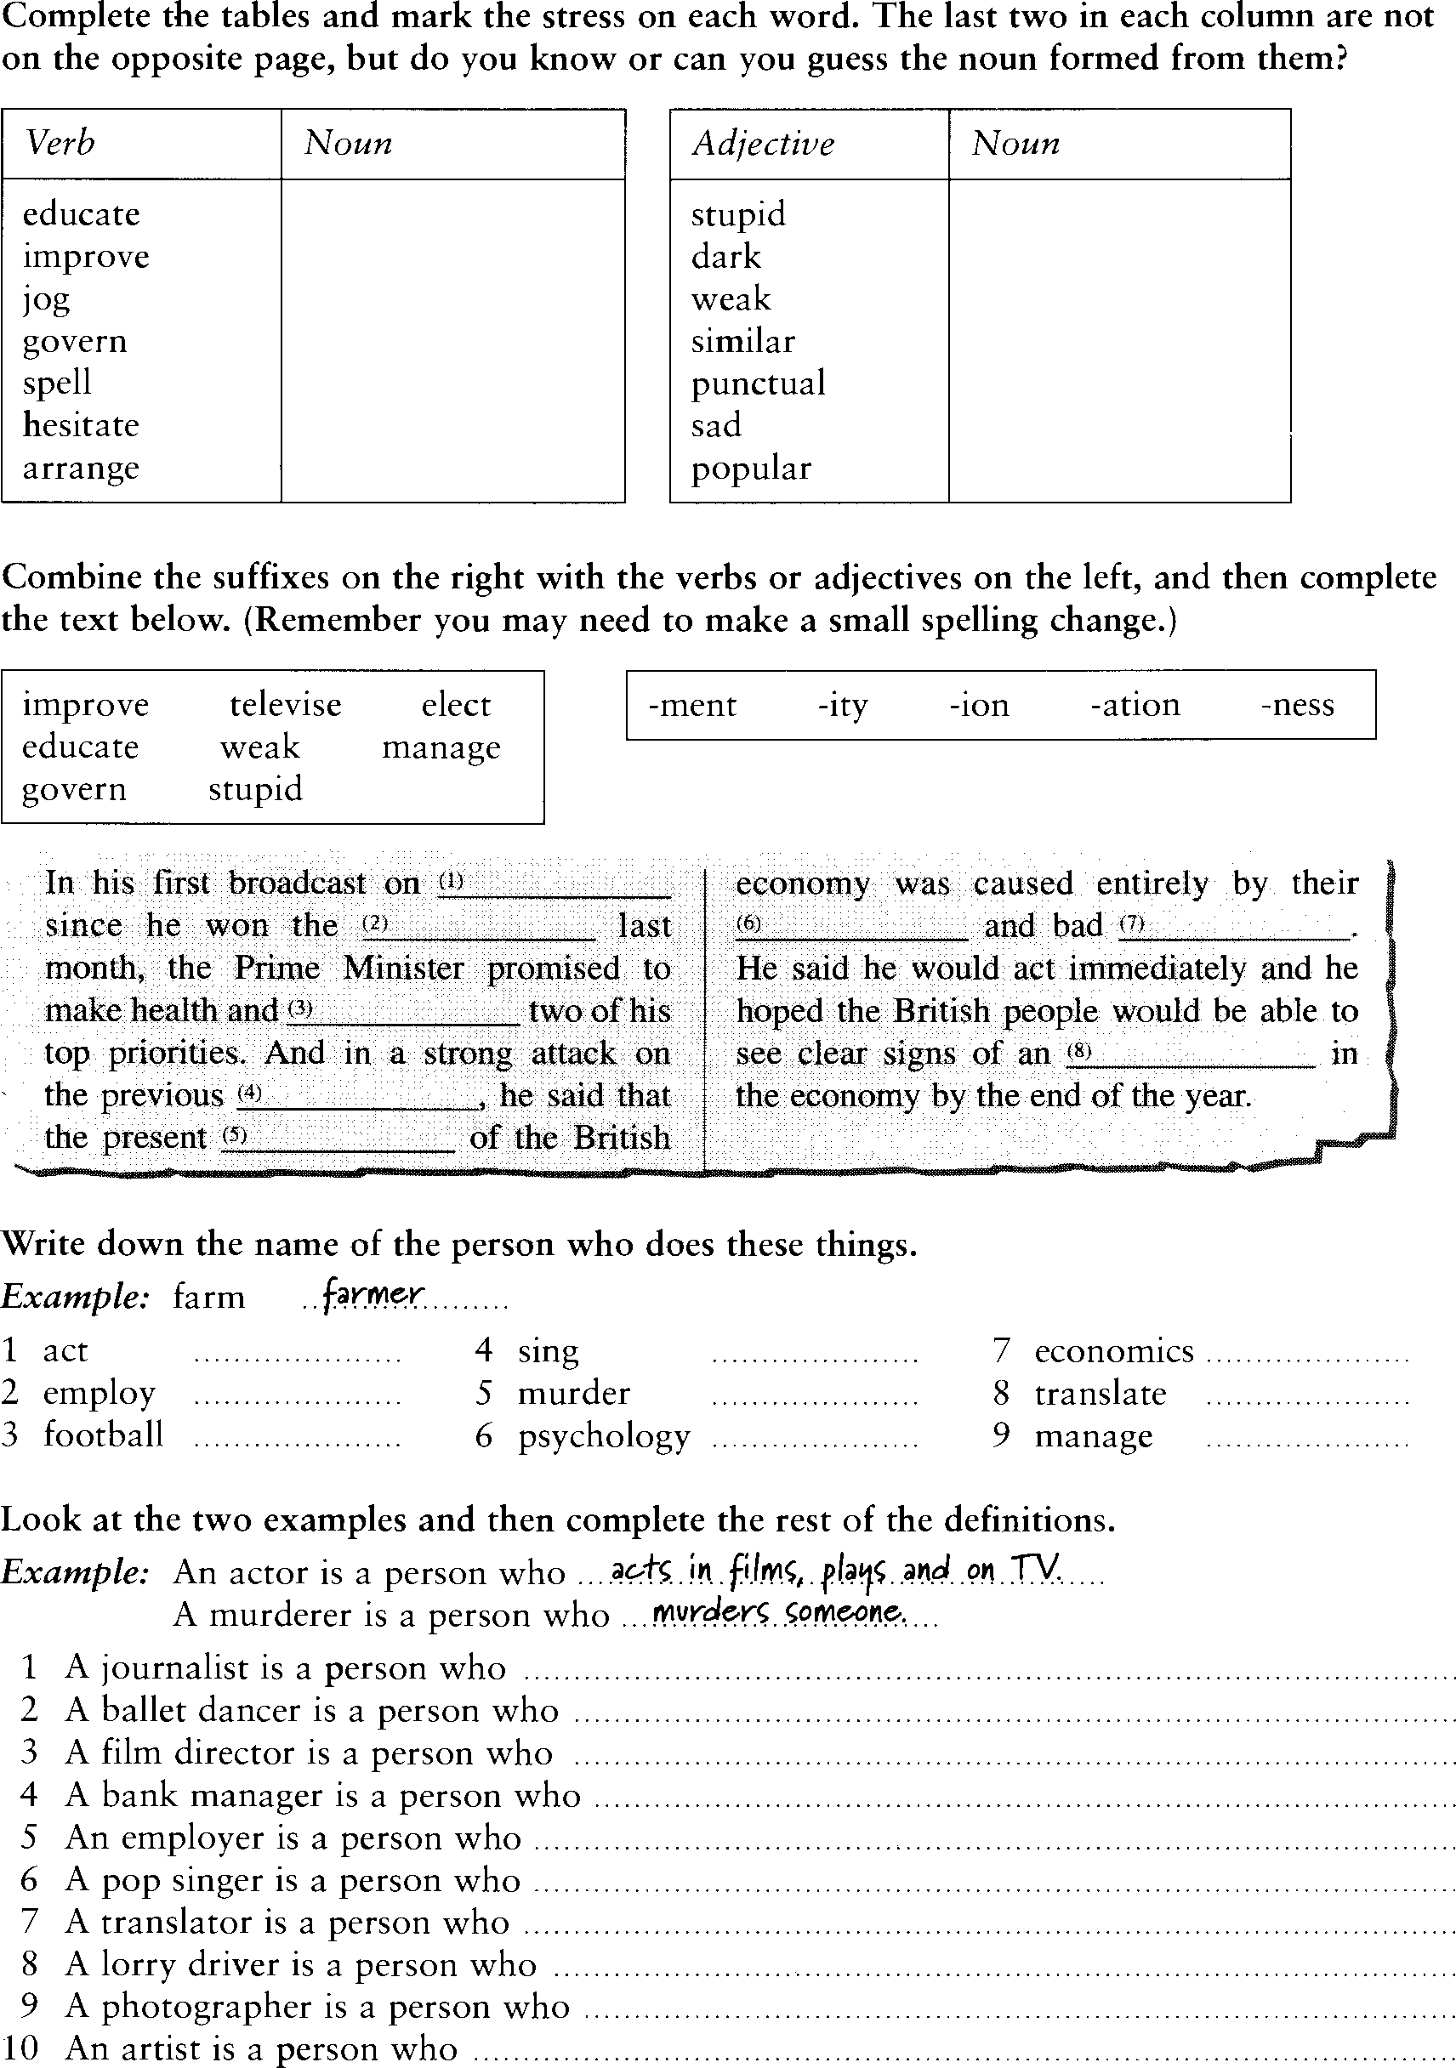

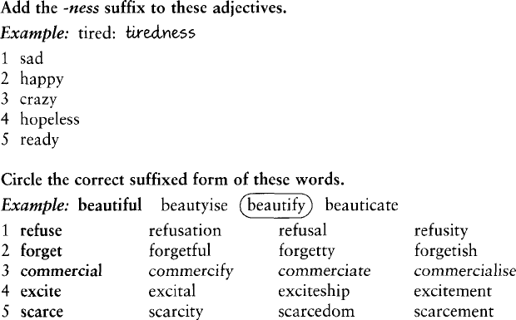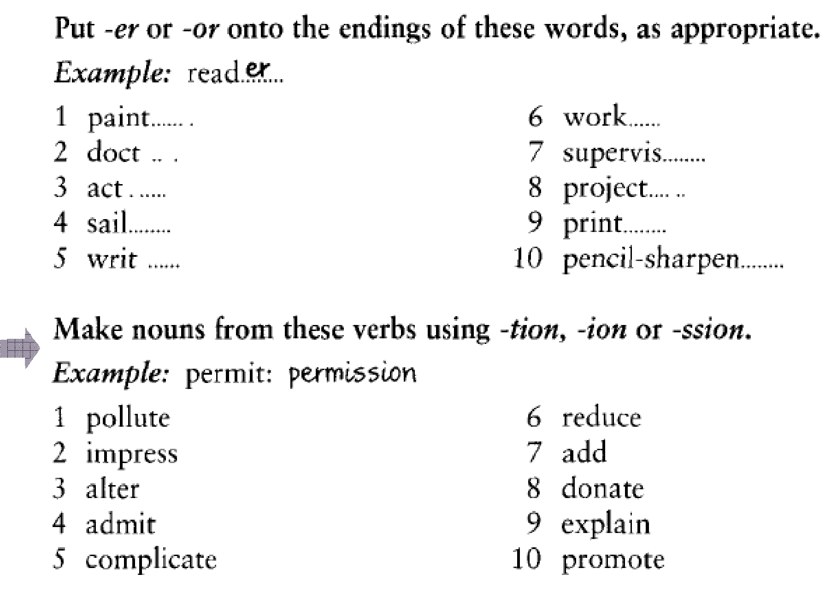

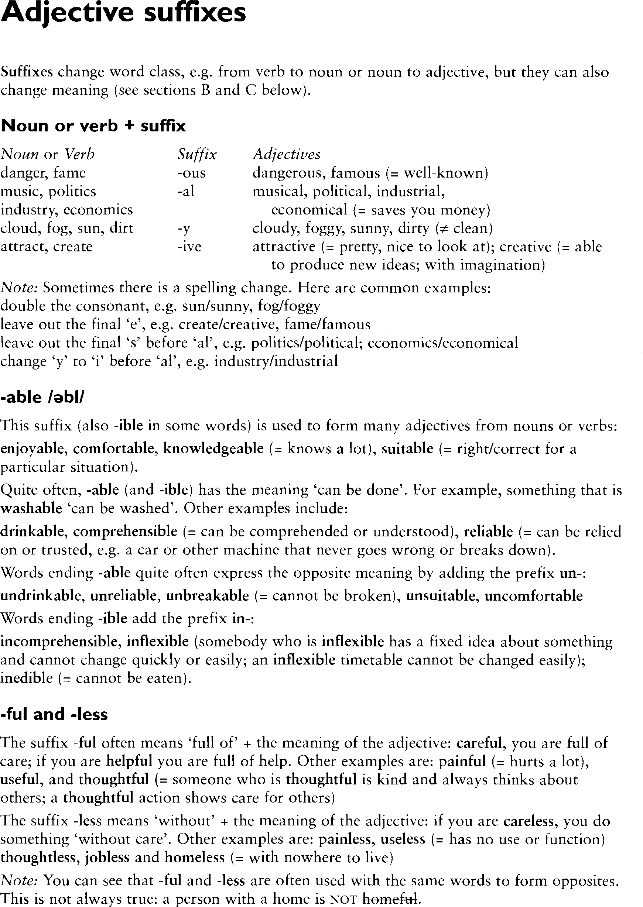

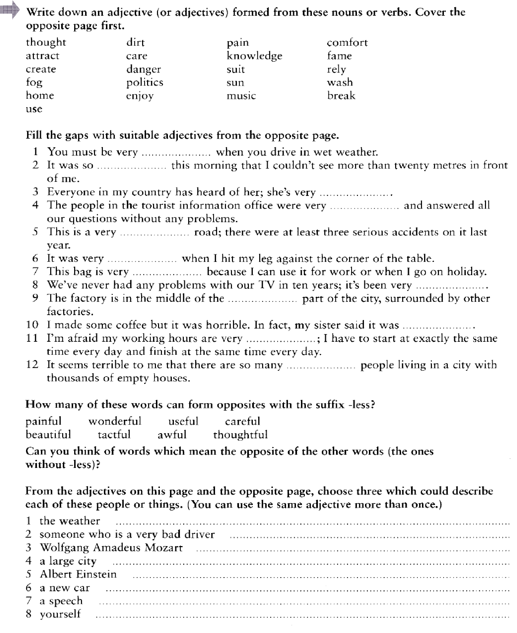

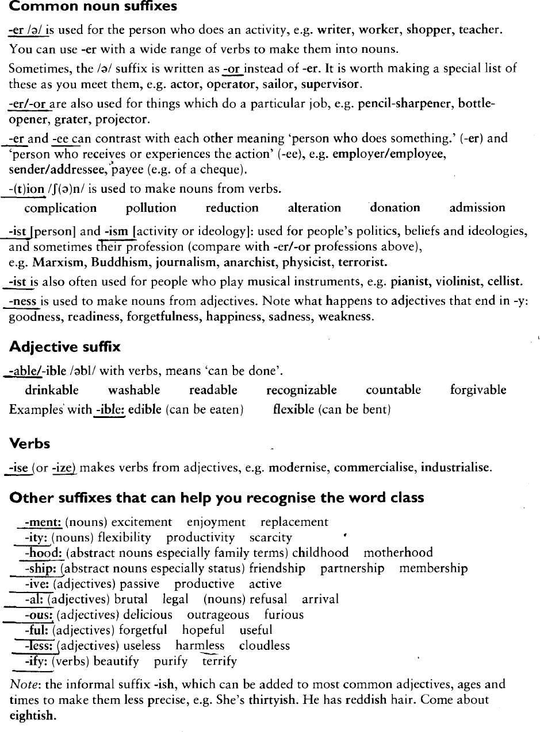

# MOST COMMON PREFIXES

|  |  |  |
| --- | --- | --- |
| Prefix | Meaning | Key Word |
| anti- | against | antifreeze |
| de- | opposite | defrost |
| dis-* | not, opposite of | disagree |
| en-, em- | cause to | encode, embrace |
| fore- | before | forecast |
| in-, im- | in | infield |
| in-, im-, il-, ir-* | not | injustice, impossible |
| inter- | between | interact |
| mid- | middle | midway |
| mis- | wrongly | misfire |
| non- | not | nonsense |
| over- | over | overlook |
| pre- | before | prefix |
| re-* | again | return |
| semi- | half | semicircle |
| sub- | under | submarine |
| super- | above | superstar |
| trans- | across | transport |
| un-* | not | unfriendly |
| under- | under | undersea |
| -able, -ible | can be done | comfortable |
| -al, -ial | having characteristics of | personal |
| -ed* | past-tense verbs | hopped |
| -en | made of | wooden |
| -er | comparative | higher |
| -er, | one who | worker, actor |
| -est | comparative | biggest |
| -ful | full of | careful |
| -ic | having characteristics of | linguistic |
| -ing* | verb form/ present participle | running |
| -ion, -tion,  -ation, ition | act, process | occasion, attraction |
| -ity, -ty | state of | infinity |
| -ive, -ative, -itive | adjective form of a noun | plaintive |
| -less | without | fearless |
| -ly* | characteristic of | quickly |
| -ment | action or process | enjoyment |
| -ness | state of, condition of | kindness |
| -ous, -eous, -ious | possessing the qualities of | joyous |
| -s, -es* | more than one | books, boxes |
| -y | characterized by | happy |

*Most frequent. The four most frequent suffixes account for 97 percent of suffixed words in printed school English.

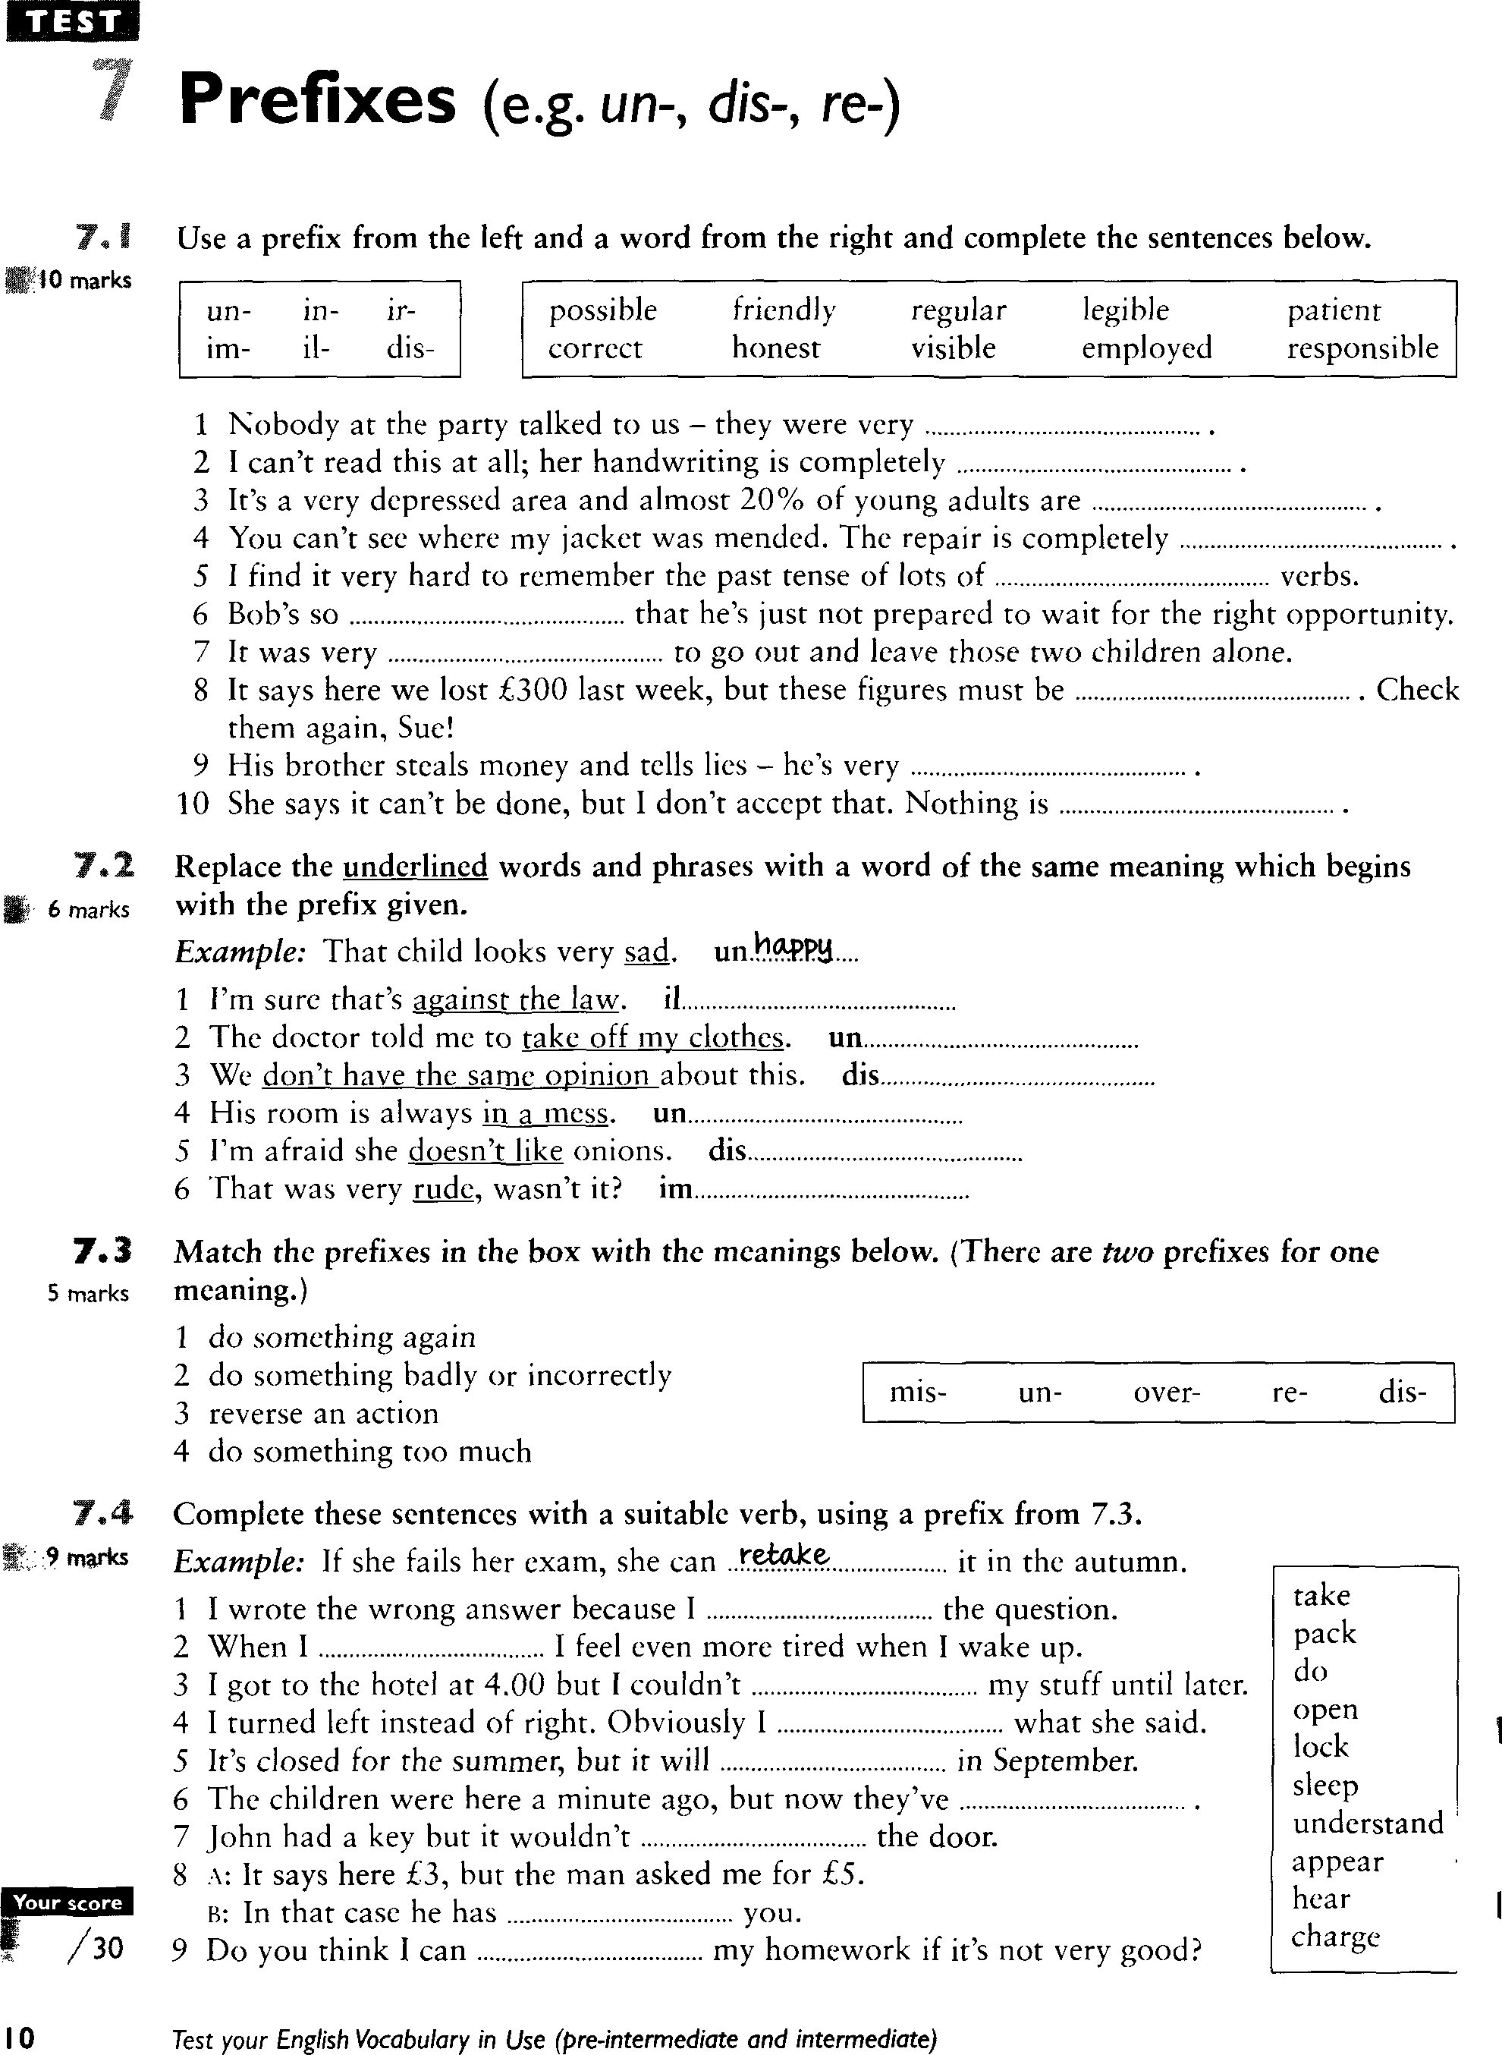

# MOST COMMON SUFFIXES

|  |  |  |
| --- | --- | --- |
| Suffix | Meaning | Key Word |
| -able, -ible | can be done | comfortable |
| -al, -ial | having characteristics of | personal |
| -ed* | past-tense verbs | hopped |
| -en | made of | wooden |
| -er | comparative | higher |
| -er, | one who | worker, actor |
| -est | comparative | biggest |
| -ful | full of | careful |
| -ic | having characteristics of | linguistic |
| -ing* | verb form/ present participle | running |
| -ion, -tion,  -ation, ition | act, process | occasion, attraction |
| -ity, -ty | state of | infinity |
| -ive, -ative, -itive | adjective form of a noun | plaintive |
| -less | without | fearless |
| -ly* | characteristic of | quickly |
| -ment | action or process | enjoyment |
| -ness | state of, condition of | kindness |
| -ous, -eous, -ious | possessing the qualities of | joyous |
| -s, -es* | more than one | books, boxes |
| -y | characterized by | happy |

*Most frequent. The four most frequent suffixes account for 97 percent of suffixed words in printed school English.

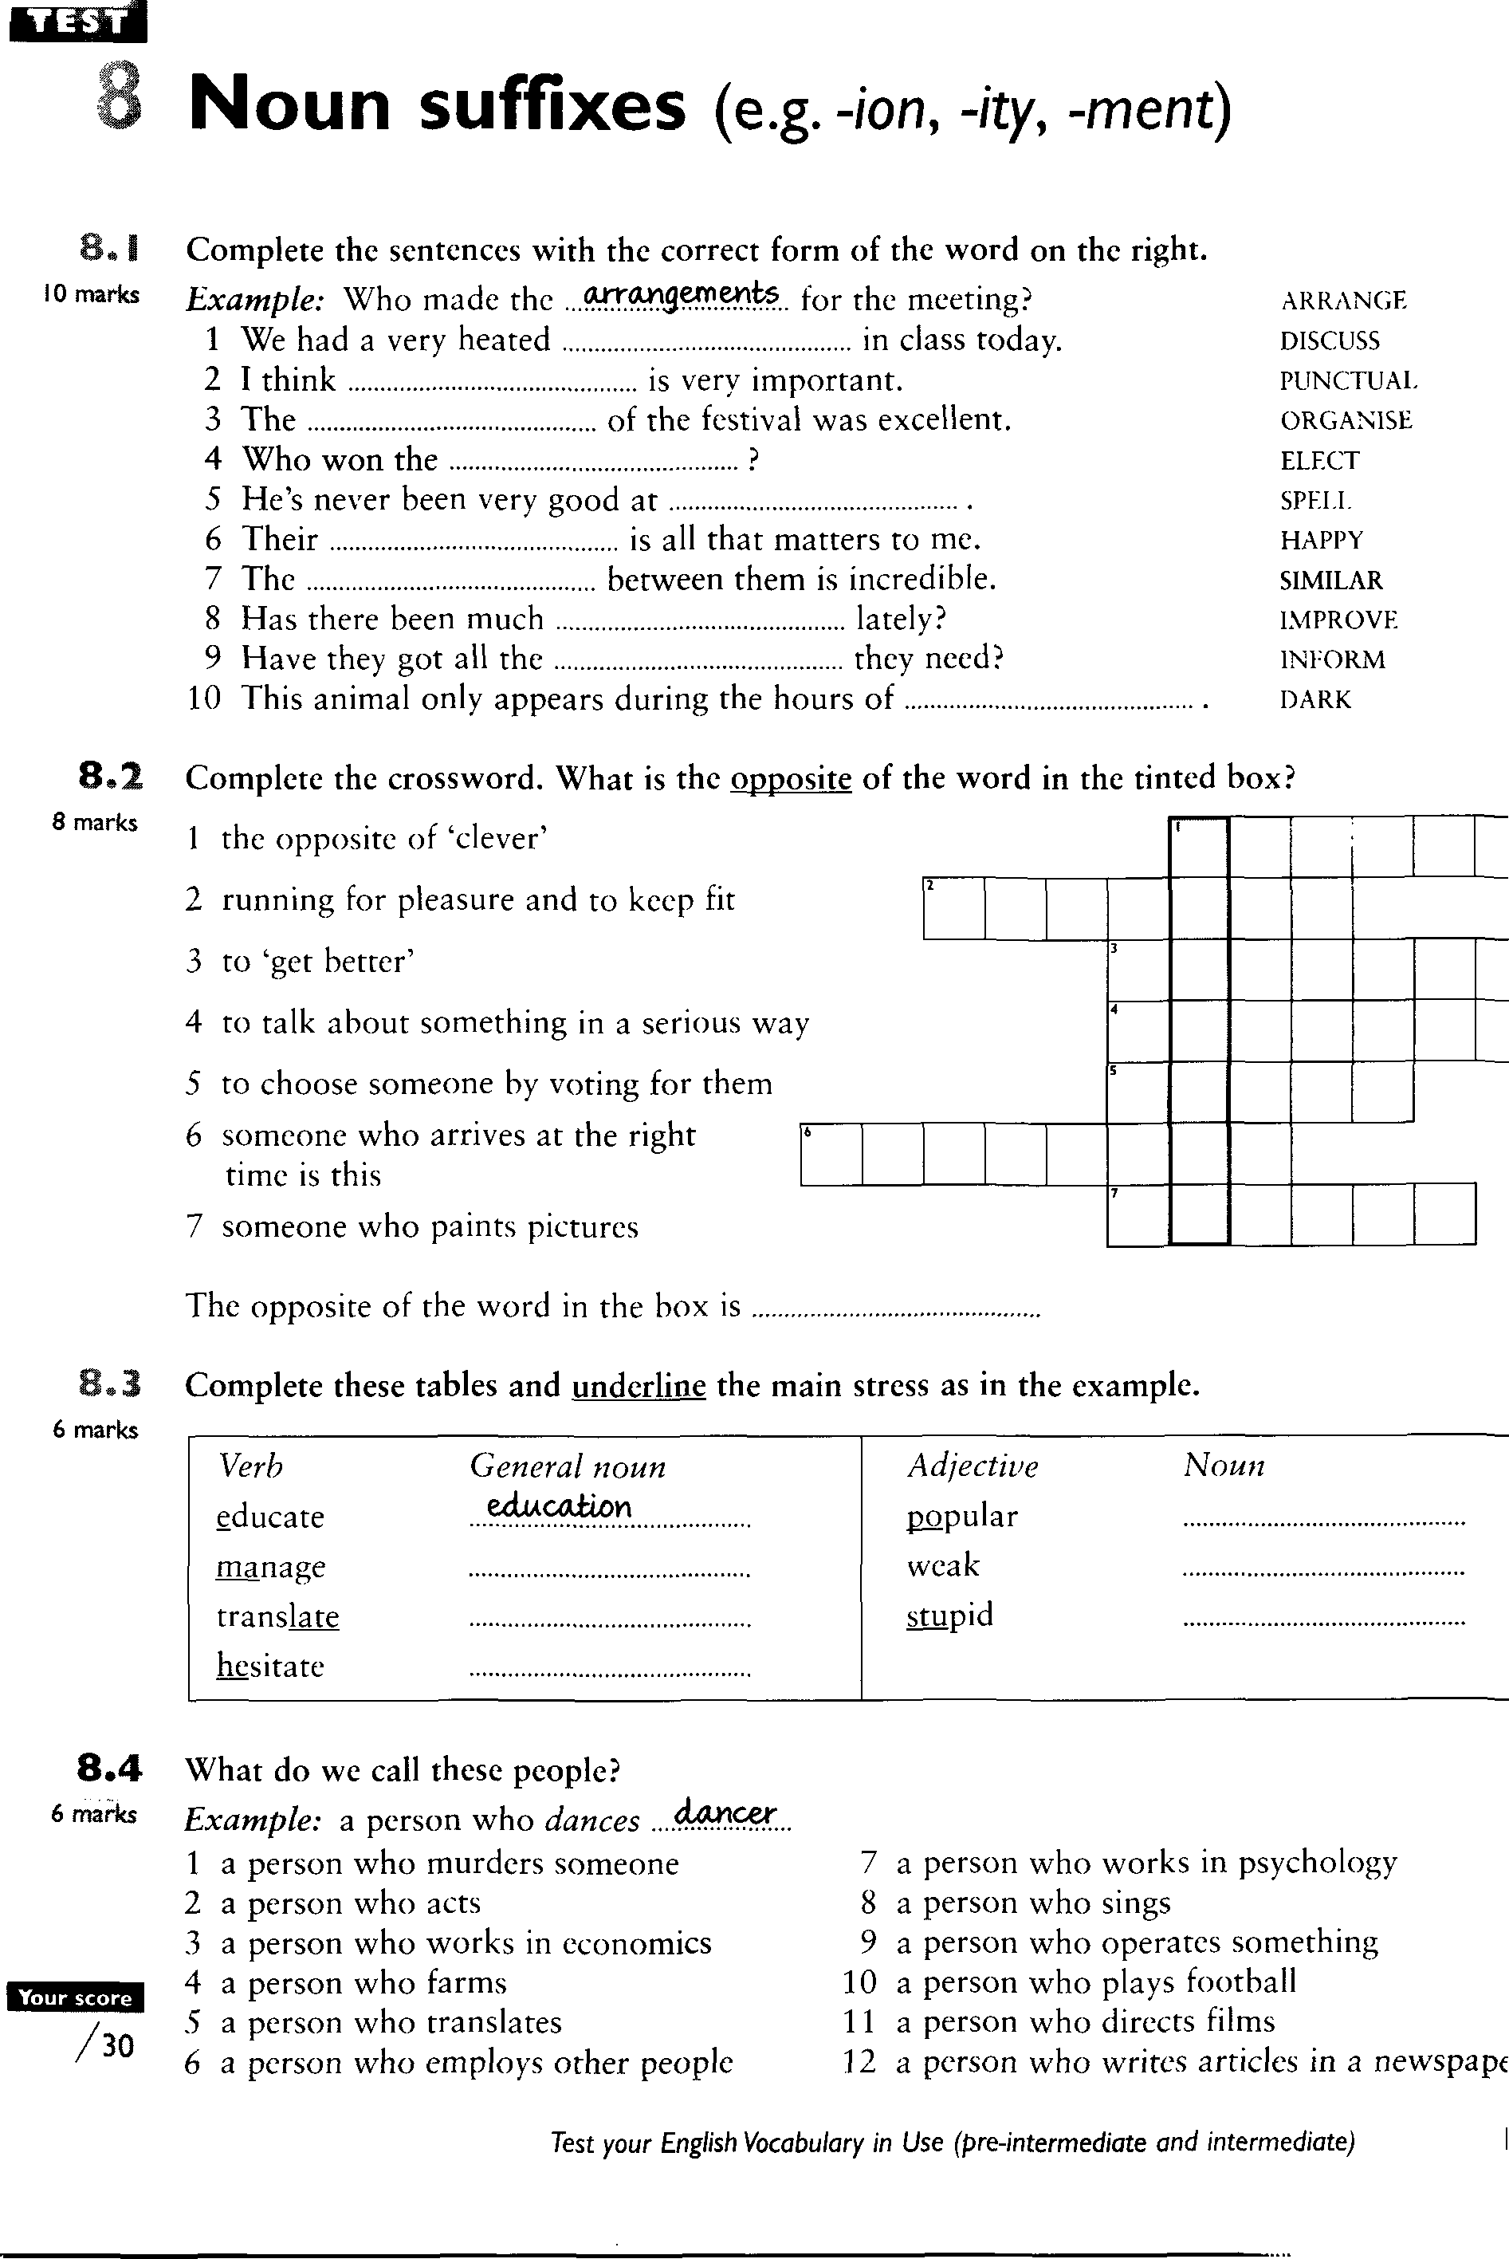

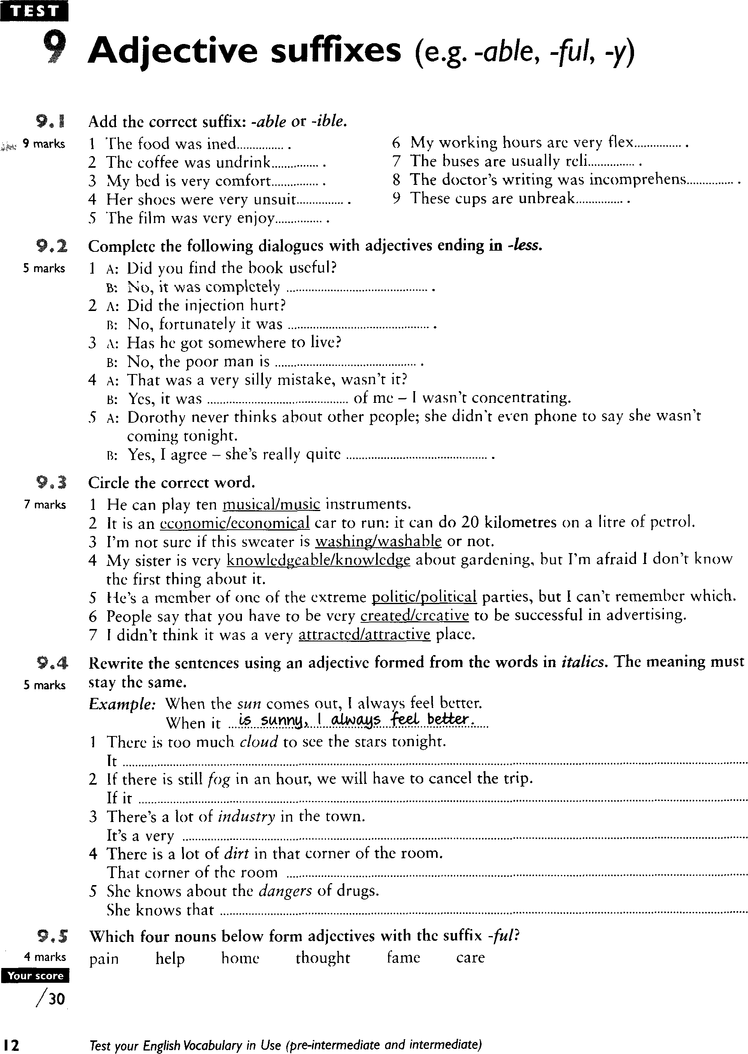

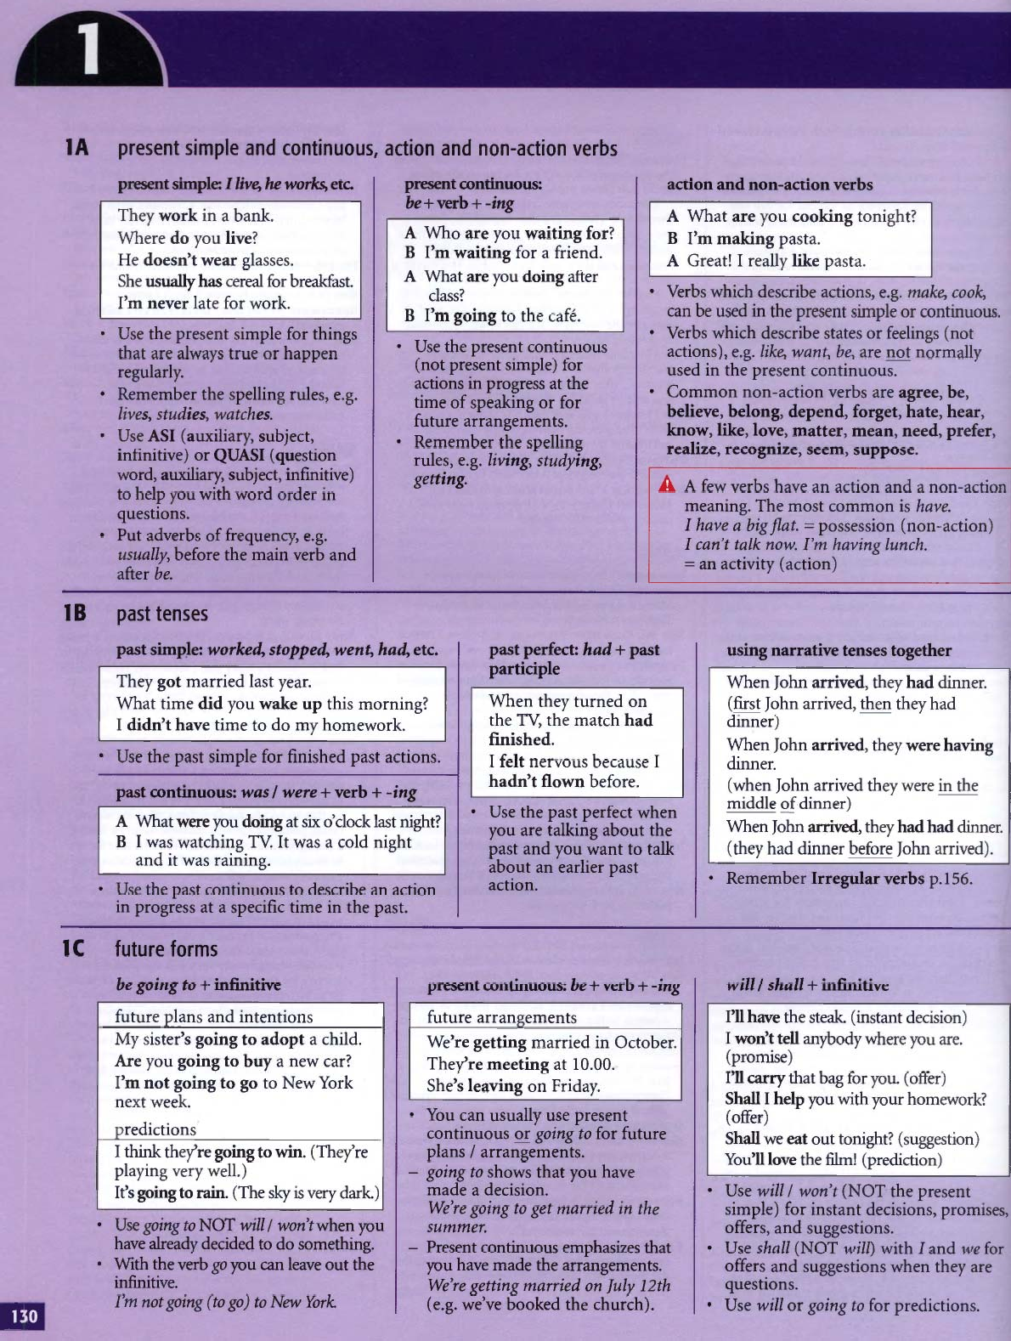

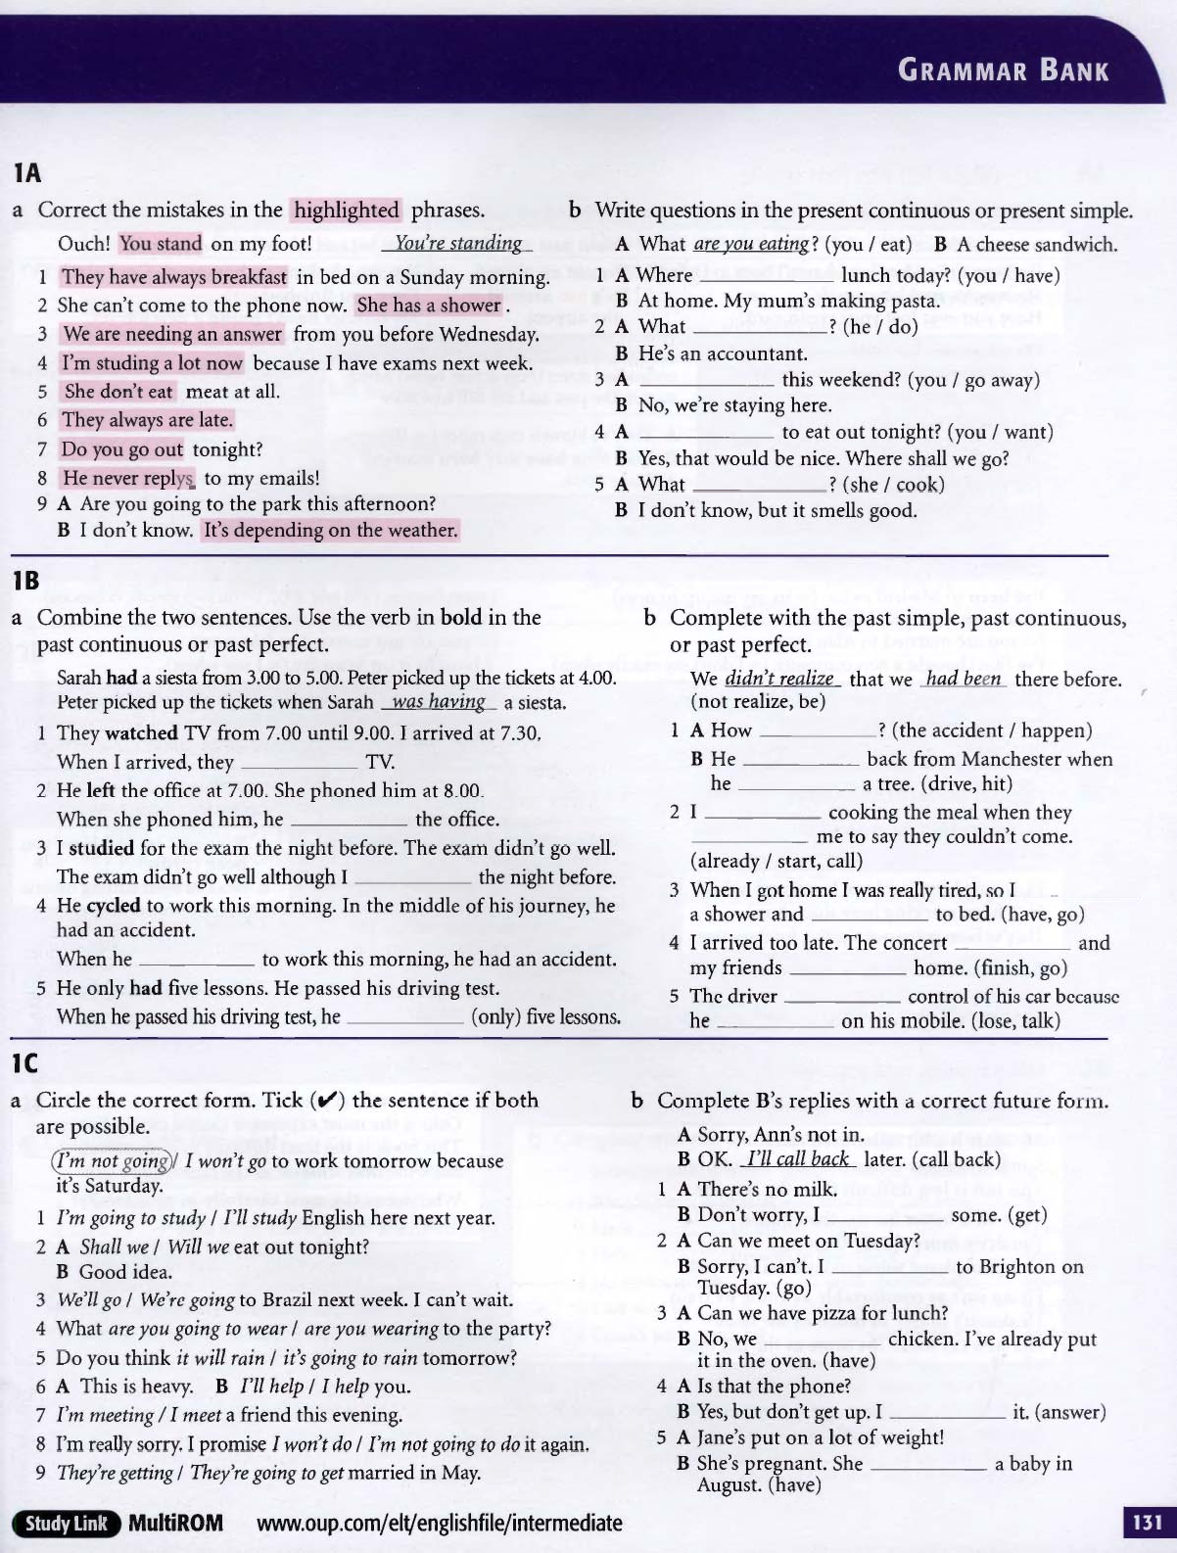

# TELEPHONING

Make a call: *hacer una llamada* / to ring / Ring me up /Call me at 4 o´clock

Take a call: *atender llamadas*

Speak on the phone: *hablar por teléfono*

Answer /pick up the phone

Call /ring up/phone: *llamar por teléfono* Can you call me tomorrow? Ring me up at 4 o´clock

Call back: *devolver la llamada*: I´ll call you back when I get to the office

# Kind of calls at work:

Looking for customers, informing customers about your products or services,arranging appointments, organising the work, informing patients about appointments, insurance, admission to hospital …., customers´complaints (*quejas de clientes*), workers‘timetables, congratulations of customers, placing orders (*hacer pedidos*), taking calls of suppliers (*proveedores*), calling suppliers …………………, making bookings or reservations, trips, events …..

# Useful language

Answering the phone: Good morning, Take away Food Elena speaking, How can I help you? / May I help you?

Identifying yourself Good morning, Peter Trafs speaking / This is Peter Trafs / It´s Peter/ It´s me *No se puede decir I am Peter en el teléfono*

The reason for the call: I´m calling to complain about……………. (*quejarme*), to inform you about, to reserve /book a table for six, to place an order of 100 units of…………..,to cancel the appointment……………………….

Can I speak to …………………../I´d like to speak to /to talk

# Identifying the caller:

Who is that? /Who is calling? *No se dice* Who are you

## The person you want to talk to is in the office

Hold the line /(Hold on *permanezca en línea)* / I´ll put you through (le *paso)*/ I´ll connect you / transfer you/ Just a moment please

The person you want to talk to is not at the office: I´m sorry but /I´m afraid (that) Mr Smith is not in the office / Is off today (*no ha venido al trabajo por algún motive)* /He´s away on a business trip/ he´s in a meeting (*está reunido)*, can´t take the call at the moment (*no puede atender la llamada)*/ his line is busy / engaged (*su línea está ocupada*)…………………………

Asking the caller to leave a message: Would you like to leave a message?/ Can I take a message?

Leaving a message: Yes, please Can you ask him to call me back? /Could you tell him that I called? / Tell him to call me when he comes back?

No, thanks, I´ll call back later / in two hours / When Will he come back? / When can I call him back? / Ok I´ll pass on your message? (*le paso su mensaje* )

# ENGLISH TENSES: PRESENT, PAST AND FUTURE

# **PRESENT SIMPLE**

|  |  |  |  |
| --- | --- | --- | --- |
| affirmative | negative | interrogative | questions |
| I work | I don´t work | Do I work? VERBO EN INFINITIVO | Where do I work? |
| You work | You don´t work | Do you work? | What time do you work? |
| He, she, it works | He, she, it doesn´t work | Does he, she, it work? | When does he work? |
| We work | We don´t work | Do we work? | …………………… |
| You work | You don´t work | Do you work? | ……………………… |
| They work | They don´t work | Do they work? | ……………………….. |

# SPELLING:

For the third person singular we add **–s** or **–es** .We add **–es** when the verb ends in:

• **ss, x, sh, ch, o:** Examples: I kiss, he kisses; I mix, she mixes ; I brush, she brushes, I catch, he catches ; I go, he goes

• verbs ending in **–y** preceded by consonant: I try, she tries, I study, he studies (But I play, he plays) I stay he stays

# USE:

## Habitual actions, routines, habits (normally with a frequency adverb)

* Examples: She never gets up before eight o´clock
* I go running every day

Permanent situations: I work in a hospital/ She lives in the center of the city

* General truths: Water freezes at 0º C; Elephants don´t fly; the sun rises in the east
* For transport or events timetables with a future meaning: The train leaves at 5 o´clock

FREQUENCY ADVERBS: always, frequently, usually, very often, often, sometimes, occasionally, rarely, hardly ever, never, every day, on Mondays…

Position: Just before the main verb  
I usually go to school by bus / She doesn´t usually take the train

But: (two word adverbs) She brushes her teeth every day, twice a day, once a week, three times a day

He goes to the Gym on Mondays and Thursdays.

When the verb is to be we place the adverb after to be: I am always happy, she´s never bored

# **PRESENT CONTINUOUS:**

FORM: present of **to be + -ing**

|  |  |  |  |
| --- | --- | --- | --- |
| Aff | Neg | Int | questions |
| I am working | I am not working | Am I working? | Why am I working? |
| You are working | You are not working aren´t) | Are you working? | Where are you working? |
| She is workingShe´s working) | She is not working isn´t) | Is she working? | What time is she working? |
| We are working | We aren´t working | Are we working? | Where are we working? |
| You are working | You aren´t working | Are you working? | …………… |
| They are working | They aren´t working | Are they working? | ……………. |

# SPELLING:

* If the verb (one syllable ) ends in **one vowel + one consonant**, we double the consonant: stop/stopping; run/running etc
* When the verb ends in –y, we don´t change anything, just add –ing: **study /studying**
* If the verb ends in –e, **we drop – e** and we add –ing: come /coming; drive /driving
* **The verbs lie and die change to lying and dying**

# USE:

* For actions in progress, happening now, at the moment or not, but in progress:
* We are studying English grammar now
* I´m reading a very interesting book ; I started it last week (not now because now I´m teaching English)
* **For fixed arrangements for the future**, that are in our diary, which are scheduled: I´m having an English test next Monday at 4 o´clock
* She´s flying to Paris at 5 o´clock this afternoon

State verbs (that express feelings or states such as: like, want, think, be, prefer, agree, believe, belong to, depend, hear, know, realize, seem, suppose, can´t be used in present continuous.

Exceptions:

I think (opinion) always in present simple /I think (*meditar, darle vueltas a algo etc* ) present continuous

Be: in present simple when describing people´s personality: She´s very nice / but She´s being very selfish today (*hoy está siendo o se está comportando de manera egoísta pero no es su actitud normal o habitual*)

-----------------------------------------------------------------------------------------------------------------------------------

# **FUTURE**

* **Be going to for plans and intentions**: Ex: I´m going to visit Susan next Saturday

**For predictions based on evidence**: If you continue walking and using

**Your mobile, you´re going to fall**

* **Present continuous for future**: They´re getting married in July
* **Will** **for instant decisions**: “I Fancy a pizza” /Don´t worry, I´ll prepare one

**For predictions**: I think the COVID pandemic Will be over in a year

* **Future perfect**: This time next year I will have finished my studies
* **Future continuous**: This time tomorrow I will be flying to London

--------------------------------------------------------------------------------------------------------------------------------------

**FORM: Regular and irregular verbs. Regular verbs form the past simple adding –ed Ej arrive past: arrived**

**Irregular verbs: 2nd column**

|  |  |  |
| --- | --- | --- |
| I lived / I drank | I didn´t live / I didn´t drink | Did I live? / |
| You lived | You didn´t live | Did you live? |
| What did you drink? |  | Did I drink? |
| He, she, it lived | He didn´t live “ | Where did I live? |
| We lived | We didn´t live “ |  |
| You lived | You didn´t live “ |  |
| They lived | They didn´t live “ |  |

* We use past simple for completed actions in a definite time of the past: yesterday, last week, two days ago, in 2007…………….
* Narration of past events

Adverbs used with the Past: last week, last year, last Monday, in 2001, yesterday, two months ago, when I was a child………………………….

**Verbs ending in consonant+ y, change to –ied Study -studied**

**But: Play – played**

**Verbs ending in one vowel + one consonant, double the final consonant: stop -stopped**

**But: Wait waited**

# PAST CONTINUOUS

|  |  |  |
| --- | --- | --- |
| I was studying | I wasn´t studying | Was I studying?  Where was I studying? |
| You were studying | You weren´t studying | Were you studying  Where were you studying? |
| He was studying |  |  |
| We, you they were studying |  |  |

Actions in progress at a certain time of the past:

Ex: Yesterday Karen and Jim played tennis .They began at 10 o´clock and finished at 11:30.

So, at 10:30 they were playing tennis. (they were in the middle of playing: they had not finished playing)

Ex: This time last year I was living in London/ What were you doing this time yesterday evening?

I waved to Helen but she wasn´t looking

# **PAST PERFECT**

Actions that took place at a previous time

I, you, he, we, you, they had worked / I hadn´t worked / Had I worked? /

Ex: Sarah went to a party last week .Paul went to the same party too but they didn´t see each other .Paul left the party at 10:30 and Sarah arrived at 11 o´clock .So, when Sarah arrived at the party, Paul wasn´t there .**He had gone home**.

**Complete the sentences. Use the verbs in brackets in the past simple.**

* ……………………………………………….. (you/see) Mary on Monday? No, I … …………………… (not go) out) but I …… …………………… (phone) her.
* He ……………………………….. (leave) the house at 8 o´clock . He ……………………… (take) a bus and ……………………………(go) to work. When he …… …………………(come back) home at 9, he ………………….(feel) very tired.
* …… ………………………………… (he /be) at home yesterday? I …………………..(call) him three times but he …………………………………..(not answer)
* I …………………………….. (meet) him last April

|  |  |
| --- | --- |
| AFFIRMATIVE | I was You were He was We were You were they were |
| NEGATIVE | I wasn´t You weren´t he wasn´t We, you, they weren´t |
| INTERROGATIVE | Was I? Were you? Was he? Were we, you, they? |
| * *No necesita el did* | |

Ex: My friend listened to music in the kitchen

* Negativa My friend didn´t listen to music in the kitchen
* Interrogativa Did my friend listen to music in the kitchen?
* Pregunta (Wh-) Where did my friend listen to music? Respuesta: In the kitchen

--------------------------------------------------------------------------------------------------------------------------------------------

CUADRO PRONOMBRES PERSONALES SUJETO, OBJETO O COMPLEMENTO, ADJETIVOS POSESIVOS PRONOMBRES POSESIVOS Y REFLEXIVOS:

|  |  |  |  |  |
| --- | --- | --- | --- | --- |
| PR.PERS. SUJETO | PR.PER.COMPL. | ADJ.POSES. | PRON. POS. | REFLEXIVO S |
| I | Me | my | mine | myself |
| you | you | your | yours | yourself |
| He | him | His (su de él) | his | himself |
| she | her | Her (su de ella) | hers | herself |
| it | it | its | its | itself |
| we | us | our | ours | ourselves |
| you | you | your | yours | yourselves |
| they | them | their | theirs | themselves |

Examples:

* I live with my brother
* You don´t like her (Susana) You don´t like him (Pedro) This is your car /That is her dress/ This is our English lesson
* This is my car and that is hers (*este es mi coche y aquel es suyo de ella*)
* *Esta es mi casa (*adjetivo posesivo*) / Esta casa no es mía (*pronombre posesivo*)* It isn´t mine
* I wash myself (*yo me lavo*)
* I wash the dress / I wash it: *Yo lavo el vestido /Yo lo lavo*

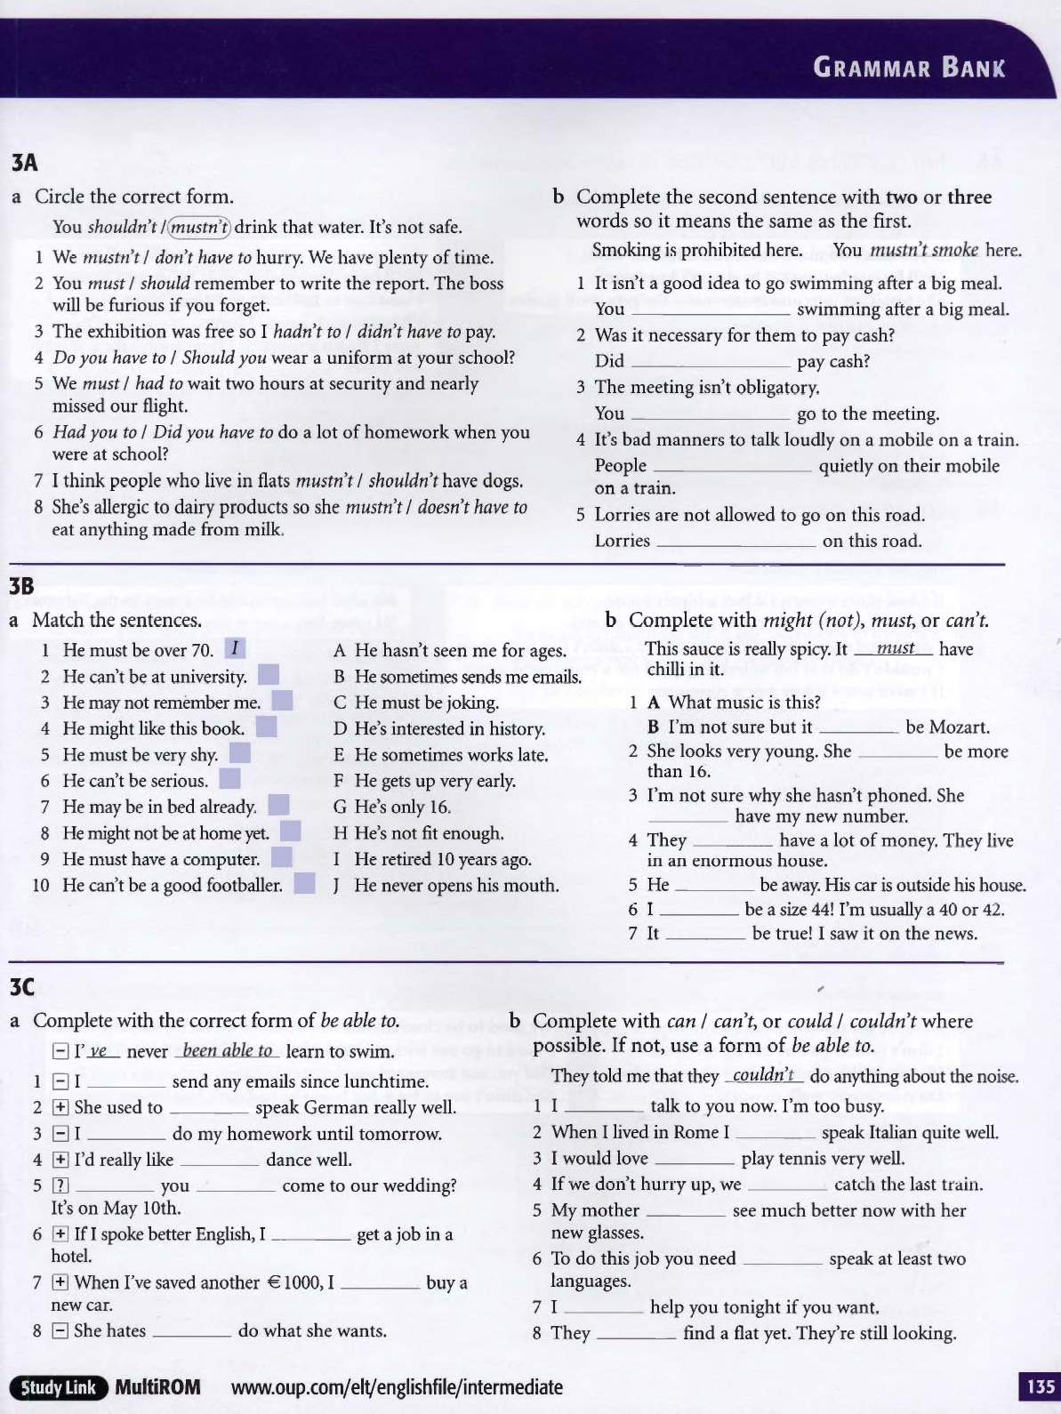

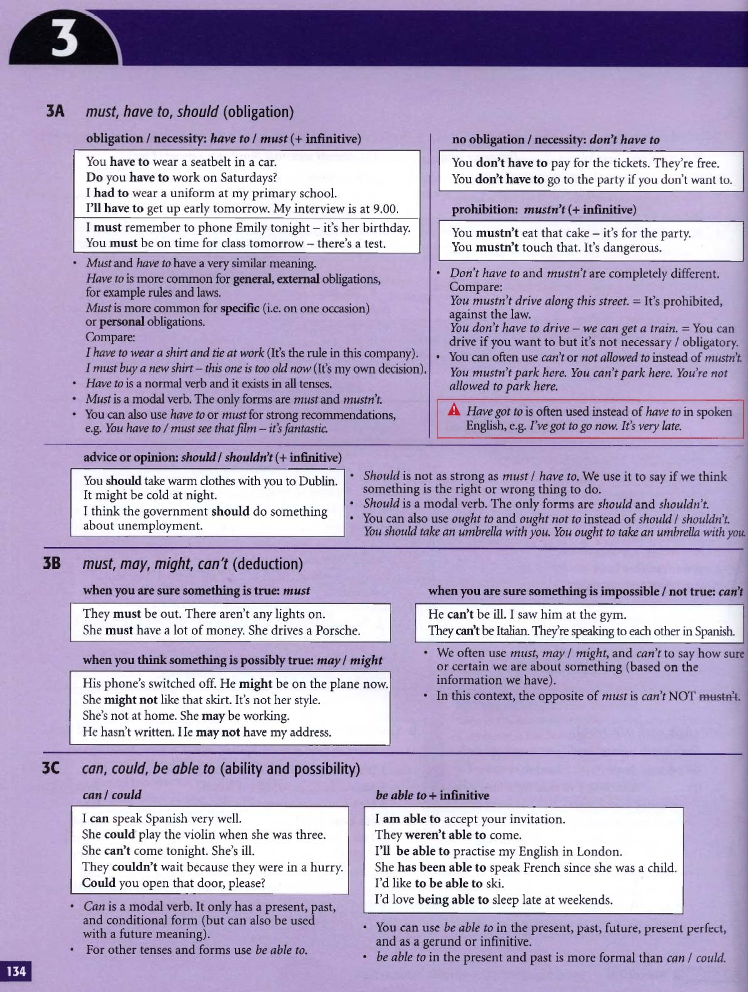

# **MODAL VERBS**

1. They do not take an -S in the third person singular: you cannot say he cans or she wills.
2. They are followed by an infinitive without ‘to’ in most cases, except OUGHT TO. Ex: You ought to study more if you want to pass the exam.
3. Also in most cases they function like auxiliaries for questions and negatives: ex: Can you speak louder, please? No, I cannot speak louder.
4. Also in most cases they do not have a past form, so we need different forms like BE ABLE TO: I will be able to speak French in two months or BE ALLOWED TO: You will be allowed to go out as soon as you are eighteen.
5. Sometimes modal verbs can also be followed by a perfect infinitive. Ex: it MUST HAVE BEEN the rain, which talks about the past.

# CAN/COULD/BE ABLE TO

* Can only has two forms can, could .sometimes it´s necessary to use be able to:

Ex: I can´t sleep well / I haven´t been able to sleep recently

Tom won´t be able to come tomorrow.

* We normally use can/could with the verbs of the senses (see, hear, smell, taste…..)

Ex: I couldn´t hear you well

* We use can for ability: I can play the piano
* In past we use could for a general ability: I could swim when I was four years old

But if somebody did something in a specific situation we have to use was/were able to: The fire spread through the building very quickly but fortunately everybody was able to escape/managed to escape (in negative both couldn´t or wasn´t able are possible)

* We use Can / Could to ask for permission and to make requests: Can I switch on the lights? Could you help me with this report?
* We use can to say that something is possible, impossible, allowed, not allowed:

Ex: I´m afraid I can´t come to the party

We are able to see the lake from our window/ We can see the lake …….. (can is more usual)

I´m sorry but you can´t smoke here

# COMPARE:

* Mike was an excellent tennis player when he was younger .He could beat anybody (general ability)
* Mike and Peter played tennis yesterday. Peter played well but Mike was able to beat him /managed to beat (that specific day)
* Pete played well but he couldn´t beat Mike
* Mike couldn´t swim
* We looked for David everywhere but we couldn´t find him7weren´t able to find him

# MUST:

The form “***must***” is for all persons and for all tenses.

***Mustn´t*** for negative, Must I? for negative .

For all other tenses we use **“ have to “ I had to, I didn´t have to, Did I have to? I have to, she has to, I will have to, ……………………………………..**

**Have to** expresses external authority, not the speaker´s authority: Tom is starting work next week, he´ll have to get up early and he hates it .

**Don´t have to, Doesn´t have to, didn´t have to, won´t have to express absence of obligation**

# MUST NOT /NEED NOT COMPARED

**Must not expresses prohibition, strong or emphatic advice or the fact that doing an action can be dangerous**:

Ex: You must not tell anyone / Visitors must not feed the animals / You must not drink this water, it´s not drinkable.

**Need not expresses absence of necessity**: You needn´t take an umbrella ; it´s not going to rain today./You needn´t make two copies of the document ; one will do .

**In past**: You needn´t have watered the plants, I did it before I went away.

# POSSIBILITY

**MAY /MIGHT**: These modal verbs are used to express probability.

They are used when we want to express an idea or activity which is not sure (it’s just probable) as we say in **Spanish** (*puede que sí, puede que no).*

**Example**: I may go to the beach on Sunday. Let’s see if I have free time at last! = ***Puede que*** *vaya a la playa el domingo* or ***igual*** *voy a playa el domingo.* *¡A ver si por fin tengo tiempo! igual hago algo…* (but I’m not sure…).

I may start learning English, but I don’t know, I prefer learning French

**Difference between ‘may’ and ‘might’**

**Might** expresses a smaller possibility/probability than ‘may’, but in fact there is little difference between them

**Negative** May + not + infinitive (without to)

I may not go to Peter’s party. I’m so tired… = *igual no voy a la fiesta de Pedro, estoy tan cansado/a…*

I might not go on holiday this year, I wouldn’t like to spend my money

May I go to the toilet? We use ‘may’ in questions to ask for permission in formal situations, as a synonym of ‘can I…?’

# DEDUCTIONS

* **With Must**: Ex: He must be very rich ; he has a house in Paris, a flat in New York and a cottage in Scotland

He must be at home; his car is parked here (positive deduction )

* **With can´t:** She can´t be so young ; her son is 20 years old (negative deduction)

# USED TO

It´s followed by to infinitive it expresse a habit in past (*solía)*

EX: I used to go to the beach every summer when I was a child

I used to be a teacher. Now I’m retired

Things used to be different = (*las cosas eran diferentes)*

BE USED TO + -ING FORM (*estar habituado a, estar acostumbrado a*). He is used to living alone

GET USED TO + -ING FORM (*habituarse, acostumbrarse*)

He got used to living alone

# EXERCISES

1. At school we do pair work. So, we ……………………………. (work) in groups

2. My father………………………………………… (have) everything done for him. But now, he himself has to do most of the things.

3. In the past people ……………………………………….. (think) that the earth was flat

4. When the Industrial Revolution started people……………………………………………. (work) long hours.

5. Starting a new job can be difficult if you …………………………………….. (get up) early.

6. I´m sure it won´t be difficult for you …………………………………. (get up) early.

7. I …………………………………(stay) in bed until late on Sunday mornings.

8. When she arrived in England, she …………………………….. (not drive) on the left, but she soon got used to it.

9. I ………………………………… (not have) milk for breakfast, I only had coffee.

10. When I was a child, I ……………………………………………..(not go) to the beach.

11. I ……………………………………… (not go out) alone until I was fifteen.

12. I will never ………………………………….. (cook) my own meals at home .

13. Susan doesn´t mind doing night shifts; she …………………………………… (go) to bed late .

14. When I worked abroad, I …………………………………….. (phone) home twice a week.

SENTENCE TRANSFORMATIONS: **Complete the second sentence using the word in brackets so that it has the same meaning as the first one:**

1. It was normal for me to watch TV for three or four hours a day

……………………………………………………………………. three or four hours a day (used)

1. After some time, living here will seem normal to you.

It will take you some time ……………………………………………………………………(used)

1. Danger is nothing unusual for soldiers.

Soldiers………………………………………………………………….(used)

1. In the past Tom was more reliable.

Tom isn´t quite as reliable ………………………………………………………………..(used)

1. Horror films weren´t my cup of tea but I like them now.

………………………………………………………………………….but I do now (use)

1. Living alone will soon seem normal to you.

You will soon …………………………………………………………….(used)

